This document shows the topics presented throughout the first semester of preparing for CCDC. Each of these topics were discussed in the meetings each week and the notes updated with every new topic covered. The website we used to learn was <https://app.letsdefend.io/>.

# Windows Fundamentals:

* File systems used in Windows:

1. File Allocation Table (FAT)- Originally intended for floppy disks but is now used for USB hard drives, flash drives, and other embedded systems
2. Extensible File Allocation Table (exFAT)- Optimized for flash memory such as USB flash drives and SD cards
3. New Technology File Systems (NTFS)- Default file system; Replaced FAT and supports Linux and BSD systems

* “Netstat” allows you to view the current network connections and their statuses
* “-a”- Displays all connections and listening ports
* “-n”- Displays addresses and port numbers in numerical form
* “-o”- Displays the owning process ID associated with each connection
* “rmdir /S *directoryName*” recursively removes a directory and all of it’s files (including the directory itself
* “type *fileName*” is used to read the contents of a file (same as “cat”)
* “rename *fileName* *newFileName” is used to rename a file
* “systeminfo” provides system info
* “dir” lists all the files and folders in the current directory (same as “ls”)
* “whoami” shows which user account is accessing the system (Format: “domain\username

Ex:

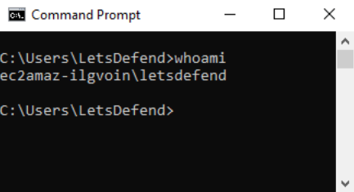

* “net” manages users and groups; the command after it indicates that indicates that a process will execute on the user/groups
* “net user” displays the usernames within the system
* To get information about a specific user, use “net user *username*”
* “net accounts” allows the user to see the configurations related to password usage and logon restrictions on the system

Ex:

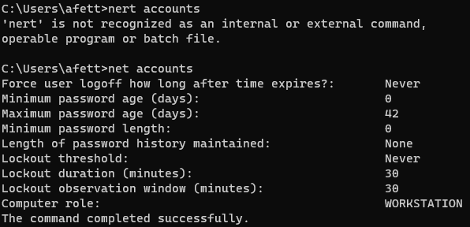

* “net localgroup” allows the user to perform operations related to the groups on the system
* Using parameters, different operations can be performed
* Without using parameters, you’ll only be able to see the groups on the system

Ex:

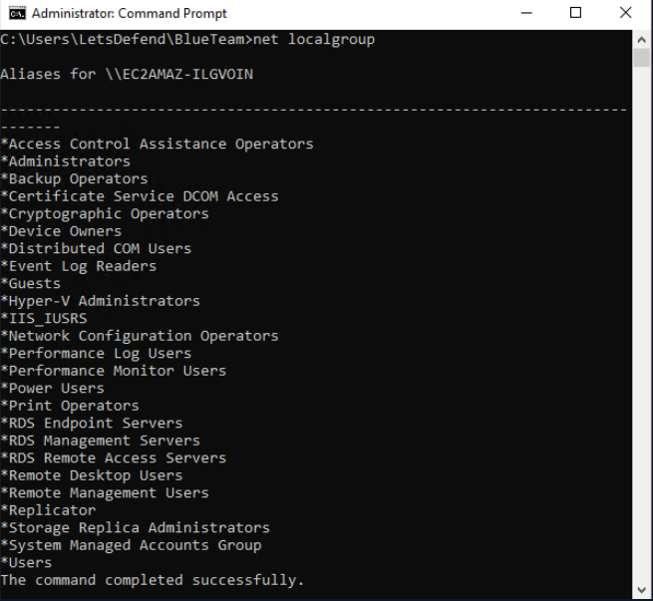

* To see information about a particular group, you can use “net localgroup R*nameOfGroup*”

Ex:

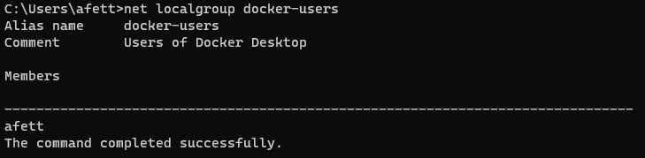

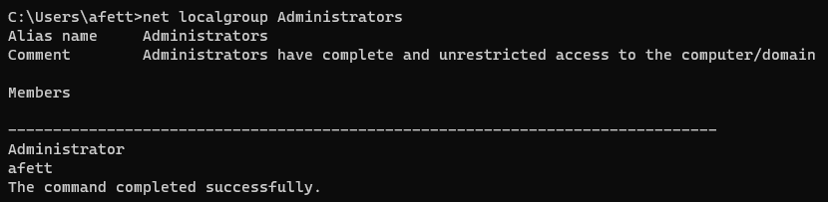

* You can use Windows Key + “r” in order to access the “run” feature which will let you open anything by typing it in

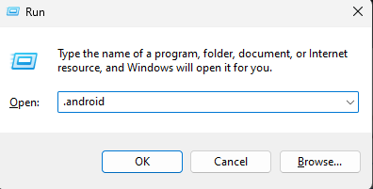

* On Windows 10, you can input “lusrmgr.msc” to open the local user management app that will let you see, create, and modify users and groups
* You can access User Account Control (UAC) setting in the “Security and Maintenance” tab in the settings
* **There are 4 levels of UAC:**

1. Always notify- Notifies whenever settings are changed or whenever an app makes changes to the computer (most annoying)
2. Notify me only when apps try to make changes to my computer (default)- Does not notify whenever settings are changed

* This is less secure because malicious programs can be created to simulate keystrokes or mouse movements made by a user and change Windows settings

1. Notify me only when apps try to make changes to my computer (do not dim my desktop)- Does not notify whenever settings are changed and does not dim the desktop whenever the prompt appears

* This is even less secure because it makes it even easier for malicious programs to simulate keystrokes or mouse movements that interfere with the UAC prompt

1. Never notify me- UAC is turned off and never notifies about when an app tries to make changes to the computer or change Windows settings

* This is not secure at all and makes the system very vulnerable to malicious apps
* The “wininit.exe” process (Windows Initialization Process) is responsible for starting the Service Control Manager (services.exe), Local Security Authority process (lsass.exe), and Local Session Manager (lsm.exe) and is located in “C:\Windows\System32” folder
* “services.exe” is responsible for starting and stopping services (located in the same folder as wininit.exe
* There should only be one services.exe process; if there are multiple, it could be due to malicious activity and should be investigated immediately
* “svchost.exe” is a generic host process name for services that run dynamic-link libraries
* Process tree:

wininit.exe

services.exe

svdhost.exe

* “lsass.exe” (Local Security Authority Subsystem Service) is responsible for critical security services such as confirming or rejecting passwords during attempted logins
* This service also works during password changes and stores passwords
* Mimikatz is used by exploiting this service and obtaining password information from it
* “winlogon.exe” controls the login and logout operations of the users in the system and is located in the same server as the wininit.exe process
* “explorer.exe” is the parent process of every process involving the GUI and opens as a window
* An example would be that this service starts whenever a program like Windows Explorer is open
* There should only be one explorer.exe on the system; if there is more than one, it may be due to malicious activity and should be investigated immediately
* In the command line:

1. “tasklist” allows you to see the list of running processes on the system
2. “taskkill” is used to terminate the process (or just one process) on the system

* The process ID (PID) of the process must be given in order for this command to work properly
* You can terminate a process be using “taskkill /PID *PIDNumber*”

1. “findstr *processName*” shows information about a particular process (including its PID)

* Ex: “tasklist | findstr osk.exe”
* The “System” process is also called “ntoskrnl.exe”
* You can open the services application by typing “services.msc” in the Run (Windows Key + “r”) window **(REMEMBER)**
* This is a powerful tool because it allows you to see the command that is being run once the application is clicked; this is definitely useful when it comes to identifying what command(s) the attackers use to infiltrate the system
* You can also show all running services in the command prompt by typing “sc query”

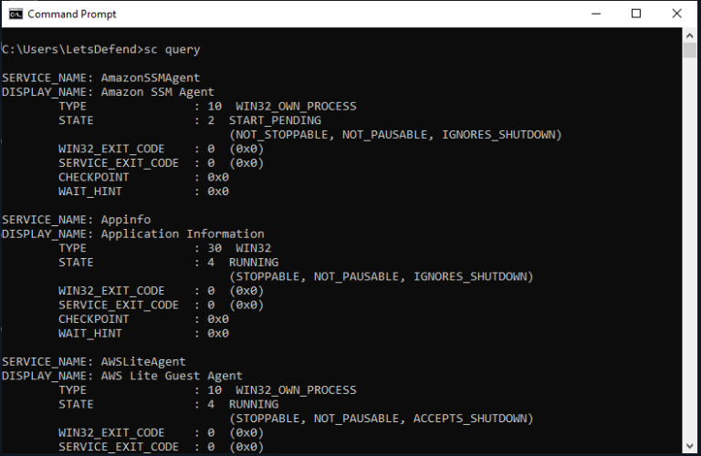

* You can display all services available in the system by typing “sc query type=service state=all”

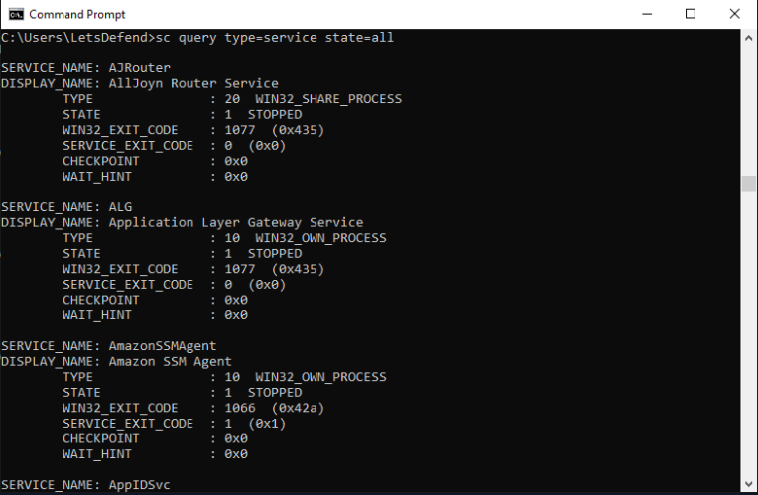

* If you want information about a specific service, you can use “sc query *nameOfService*”

**Ex- To find the information about the Windows update service:**

“sc query wuauserv”

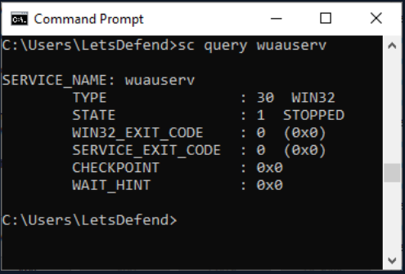

* To start a service, use “sc start *nameOfService*”
* Likewise, use “sc stop *nameOfService*” to stop a service
* **The above commands can only work if the terminal is run as an administrator**
* To open up the task scheduler, open the Run window and type “taskschd.msc”
* You can also access the scheduled tasks by running “schtasks” in the command prompt
* If you want to view a specific task, type “schtasks /Query /TN *taskName*”
* “TN” = TaskName

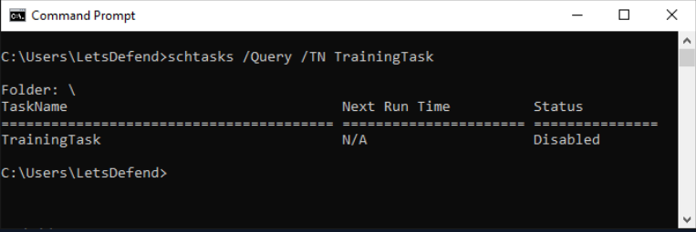

* If you want to enable a scheduled task, type “schtasks /Change /ENABLE *taskName*” (and vice versa for disabling)

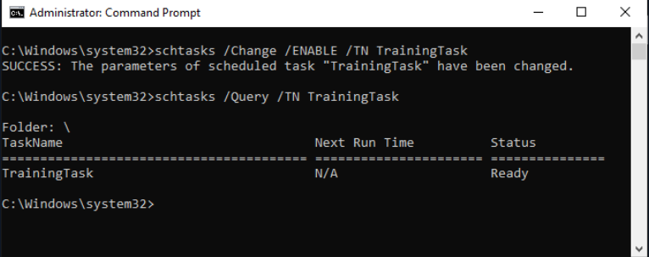

* If you want to run a scheduled task, type “schtasks /Run /TN *taskName*”

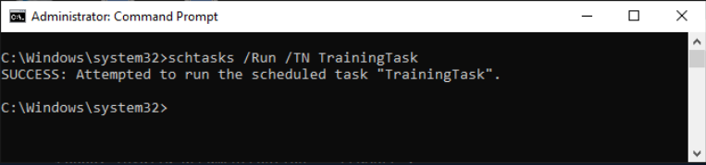

* To end a task, type “schtasks /End /TN *taskName*”

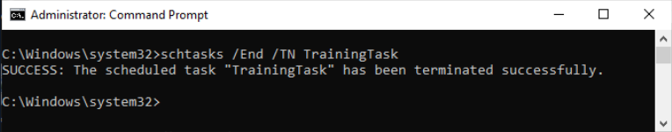

* To delete a task, type “schtasks /Delete /TN *taskName*”

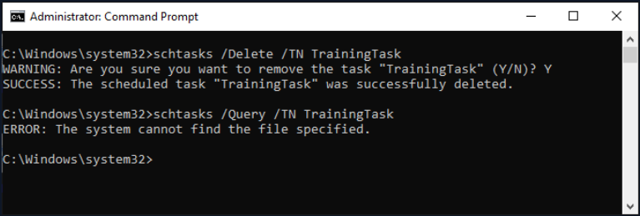

* To access the Registry Editor, type “regedit” in the Windows Run application
* This is located in the System32 directory
* There are seven predefined root keys:

1. HKEY_LOCAL_MACHINE (HKLM)

* Holds computer-specific hardware and software configuration information
* HARDWARE- This section contains information about the hardware devices connected to the system
* SAM- This section contains the encrypted versions of the passwords of the users
* SECURITY- The section that contains the security policies in the system
* SOFTWARE- This section contains the configurations of the operating system services as well as the programs installed in the system
* SYSTEM- The section where the configuration information of the system is kept

1. HKEY_CURRENT_CONFIG (HKCC)

* The section that contains the hardware configurations

1. HKEY_CLASSES_ROOT (HKCR)

* Contains software settings, shortcuts, and all other user interface-related information (if this id deleted, none of the files will open)

1. HKEY_CURRENT_USER (HKCU)

* This is the section where the configurations of the logged-in user are kept

1. HKEY_USERS (HKU)

* This is the section where the configurations of all users registered to the system are kept

1. HKEY_PERFORMANCE_DATA (only in Windows NT, but invisible in the Windows Registry Editor)
2. HKEY_DYN_DATA (only in Windows 9x, and visible in the Windows Registry Editor)

* If a file is saved as a “.reg” file, it means that it’s an export from the registry files
* You can open the Windows Firewall application by typing “wf.msc”
* You can also view it from the command line using “netsh”
* To see all the firewall rules, type “netsh advfirewall firewall show rule name=all”’

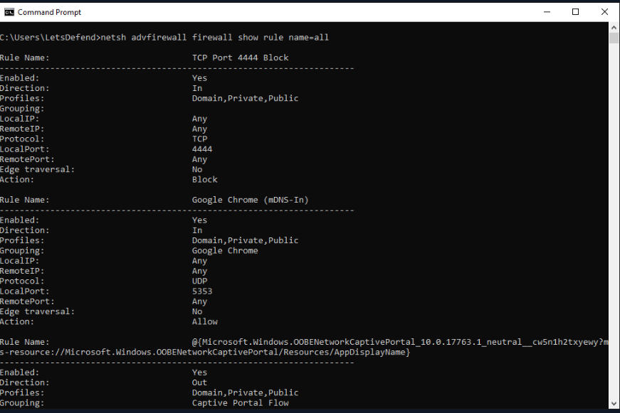

* If you want to find a particular rule, replace “all” with the name of the rule
* You can also delete a rule by typing “netsh advfirewall firewall delete rule name=*nameOfRule*”

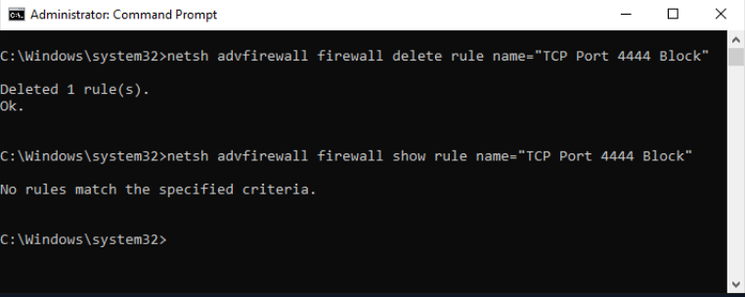

* Seven event logs:

1. Powershell activities
2. Deleting event logs
3. Starting and stopping services
4. Creating a new scheduled task
5. RDP activity
6. Changing user privileges
7. Failed login activities

* In Windows systems, there are three main event log titles: Application, System, and Security
* Application- Provides log records related to the applications in the system; you can find errors received by an antivirus application running on the system
* System- The area where the logs created by the basic components of the operating system are located
* Security- Records regarding authentication and security are kept here
* You can access the event viewer application by typing “eventvwr” in the run application
* The event ID value for unsuccessful login attempts is “4625”
* You can also examine event logs by typing “wevtutil” in the command prompt

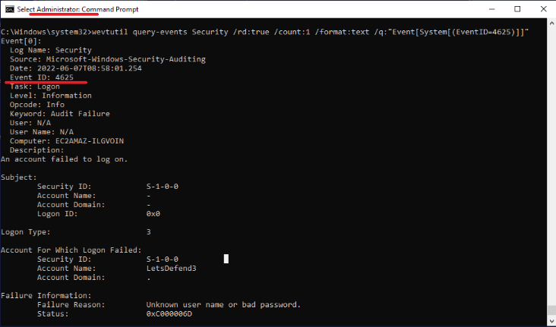

* Command: “wevtutil query-events Security /rd:true /count:1 /format:text /q:"Event[System[(EventID=4625)]]”
* "query-events" parameter : Query events from a log or log file.
* "/rd" parameter : Reverse direction.
* "/count" parameter : Log count.
* "/format" parameter : Output format.
* "/q" parameter : XPathQuery.
* Windows Management Instrumentation (WMI)- A feature to access components of the Windows OS (both local and remote access)
* Lateral Movement- Called the attacker’s movement by gaining access on other machines in the same network after obtaining the first access on the target system (attackers can remotely run executable files using WMI
* You can access WMI by typing “wmic” in the terminal
* To access information about the OS, type “wmic os list brief”

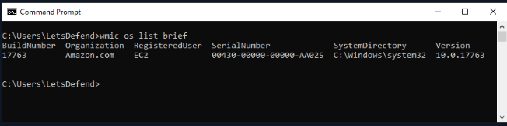

* 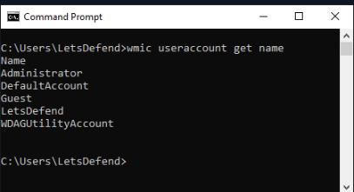You can also see the names of the users in the system by typing “wmic useraccount get name”

# Linux Fundamentals:

* Filesystem Hierarchy:

1. “/”- Root directory/Parent directory
2. “/bin”- Binary files of executable commands
3. “/boot”- Files needed when the OS turns on
4. “/dev”- Device files; Provides access to the disks on the system
5. “/etc”- Configuration files on the system

* Most important directory for security (contains encrypted passwords)

1. “/home”- Personal files from users (Downloads, Documents, etc.)
2. “/lib”- Library files used by the executable binaries in the system
3. “/media”- Holds removable media (CD-ROMs, USBs, etc.)
4. “/mnt”- Holds the temporarily mounted file systems
5. “/otp”- Holds the application software installation files
6. “/proc”- Contains files that hold information about the current status of the running processes on the system
7. “/root”- Can contain critical information; admin directory (belongs to the root user)
8. “/run”- Holds information about the running system since the last boot of the system
9. “/sbin”- Holds the binaries of executable commands (usually only accessible to the root user)
10. “/srv”- Contains the data for the services offered by the system (TFTP, FTP, etc.)
11. “/tmp”- Stores temporary files (usually deleted upon system reboot)
12. “/usr”- Contains executable binaries, libraries, and other files that all users of the system can access with read-only privileges
13. “/var”- Variable directory; Contains system logs, files (for tracking user activity), and cache files

* This directory is important because the SOC analyst can see if there was any unauthorized access to the system and take necessary action
* The “whatis” command allows you to view a single line of brief information about the commands running on the command line (“Ex: whatis whatis”)
* You can switch to the last directory using “cd -“
* You can view the total number of lines (“wc -l”), words (“wc -w”) and characters (“wc -m”) using “wc”
* You can alphabetically sort a file’s contents be using “sort *nameOfFile*”
* To view a file without duplicates, use “uniq *nameOfFile*
* “uptime” gives information on how long the system’s been running for
* “history” shows the history of commands executed in the terminal
* You can search for files by using the “find” command

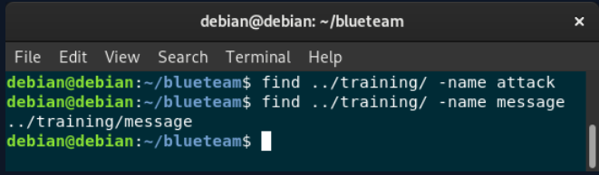

* To find a directory:

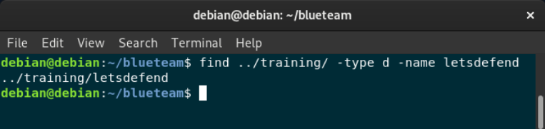

* User-permissions:

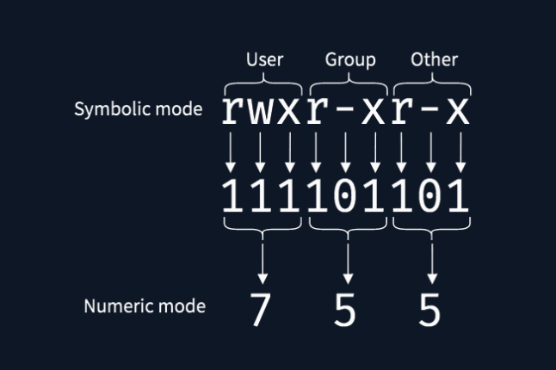

* The numerical values are represented in octal
* You can change the owner of a particular file by typing “sudo chown *nameOfNewOwner* *nameOfFile*”

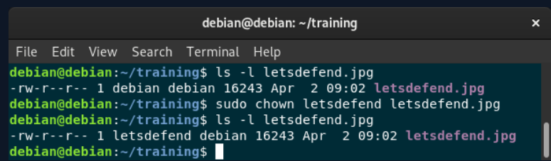

* You can change the group of a particular file by typing “sudo chgrp *nameOfGroup* *nameOfFile*”

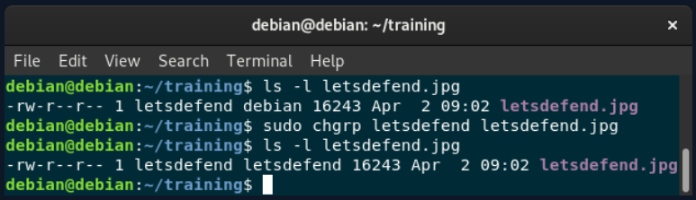

* You can see a user ID by typing “id -u”
* By default, the root UID is 0
* By typing “id”, you can see the groups that the user belongs to
* The “etc/shadow” file contains the user’s (respectfully):

1. Username
2. Encrypted password
3. Date of the last password change
4. Minimum password age
5. Maximum password age
6. Password warning period
7. Password inactivity period
8. Account expiration date
9. Reserved field for future use

* The “/etc/passwd” file contains the entire user list in the system and can be read by normal users (unlike the “etc/shadow” file)
* Its contents include users’ (respectfully):

1. Username
2. Password (if there is an “x”, then it is stored in the “etc/shadow” file, if there is a “*”, then the user does not have login access, and if there is a blank field, it means the user doesn’t have a password)
3. User ID (UID)
4. Group ID
5. GECOS field (place to leave comments about the user or account)
6. Home direcrory
7. Shell

* You can add a new user by typing “sudo useradd *nameOfUser*”
* You can also delete an existing user by typing “sudo userdel *nameOfUser*”
* To change a user’s password, you can type “sudo passwd *nameOfUser*”
* To switch users, type “su *nameOfUser*”
* The “/etc/group” file contains the groups on the system

**Archive File Formats:**

* You can compress a file into a gunzip file by typing “gzip *nameOfFile*”
* To unzip it, type “gunzip *name of file*”
* You can compress multiple files into a single archive by typing using tar (from there, you can compress it using gzip)
* Syntax: “tar cvf *nameOfArchive* *nameOfFile1* *nameOfFile2* (etc)”, where c = creation (for archive), v = verbose output, and f = allows for the name of the file archive to be written
* You can extract the files from a tar file by typing “tar xvf *nameOfTarFile*”, where x = extraction, v = verbose output, and f = file name
* You can also zip files by typing “zip *nameOfZipFile* *nameOfFile1* *nameOfFile2* (etc)”
* If you want to unzip a file, type “unzip *nameOfZipFile*”
* You can also create a .rar archive by typing “rar a *nameOfRarFile* *nameOfFile1* *nameOfFile2* (etc)”, where a = archive (specifies that an archive will be created)
* You can extract the files in a .rar file by typing “unrar e *nameOfFile*”, where e = extract

**Process Management:**

* To look at current processes, type “ps”
* If you want an even more detailed explanation about every process, type “ps aux” (the most recent command run will be at the bottom)

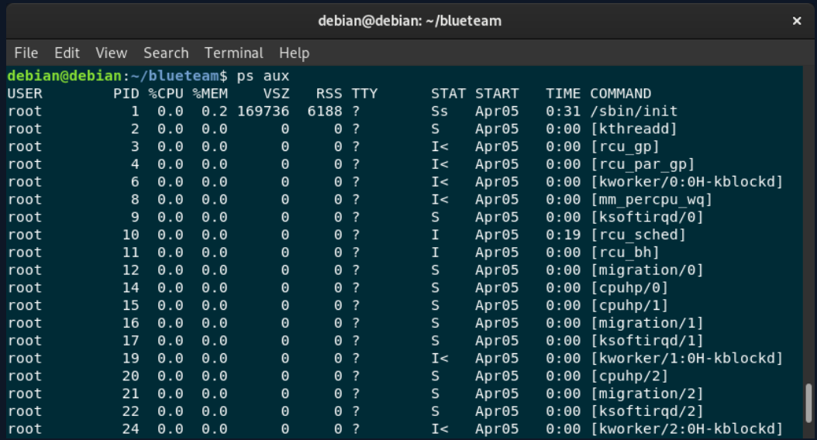

* You can also view a specific process by typing “ps --pid”
* By typing “top”, you can view the processes as they are running (whether they’re being executed or stopping) in an interactive environment (you can exit this by pressing “q”)

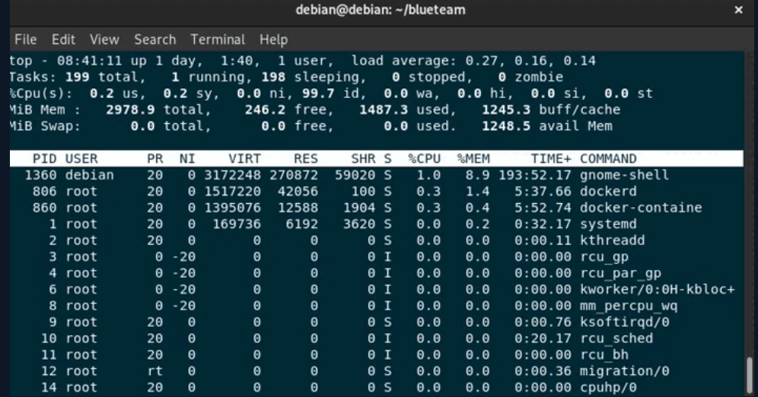

* You can also kill a process if it’s not needed or taking up too much CPU memory using the “kill” command

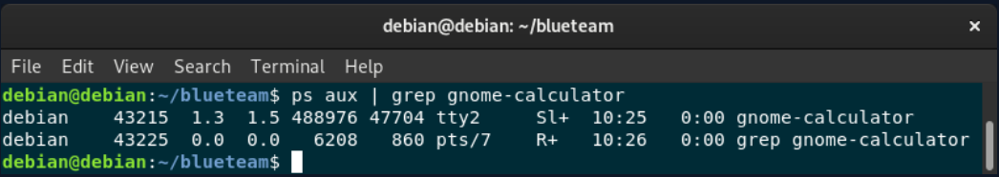

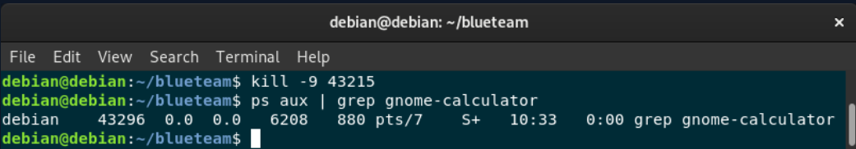

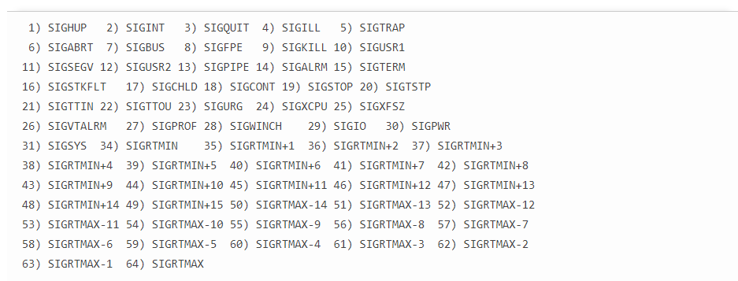

* If “kill *PID*” does not work, you can type “kill -KILL *PID*”
* The “pstree” command displays a tree of processes so it is either to navigate

**Network Management:**

* To view interface configurations, type “sudo ifconfig -a”, where -a = all (shows all interfaces
* The “dhclient” command allows you to obtain an IP address from the DHCP server

Ex:

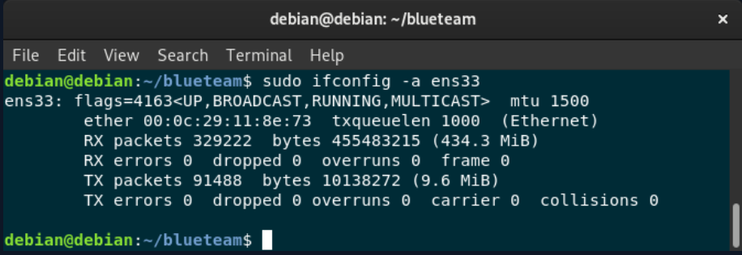

Assign a dynamic IP address to the interface:

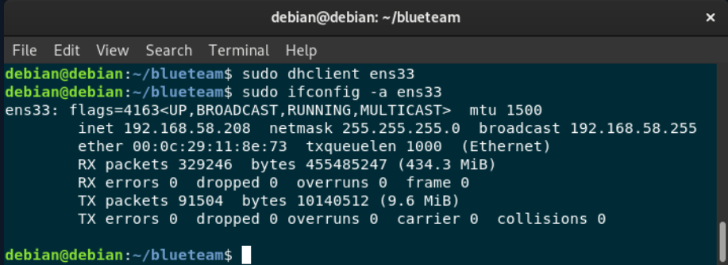

* You can also disable an interface by typing “sudo ifconfig *nameOfInterface* down”
* Conversely, you can use “sudo ifconfig *nameOfInterface* up” to enable an interface
* To assign a static IP address, type “sudo ifconfig *nameOfInterface* *IPAddress*”
* The interface MUST be down before assigning a static IP address
* You can view the current network connections by typing “netstat”

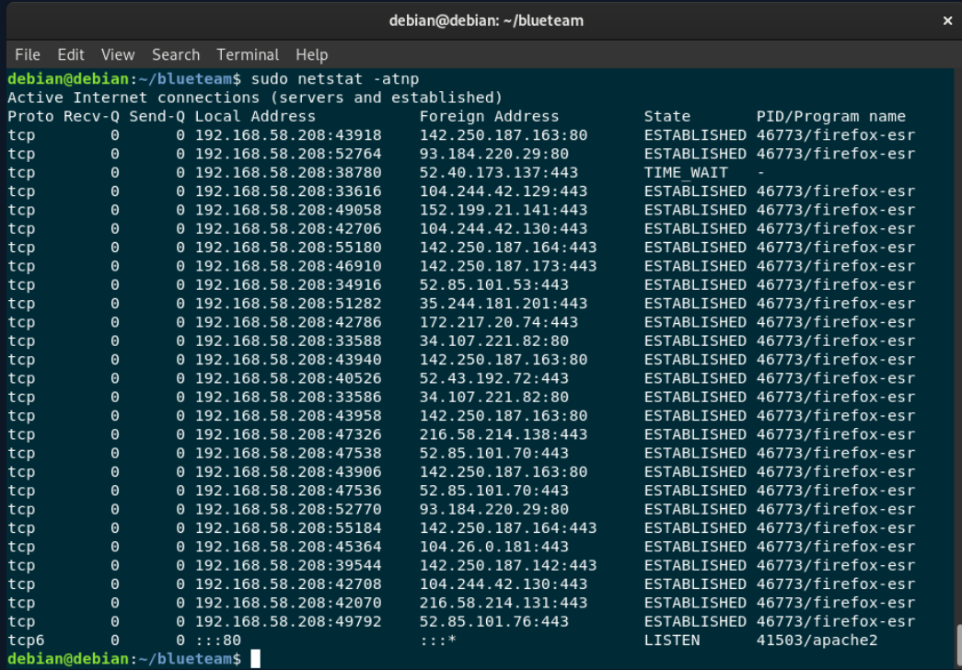

* Where:

1. -a = All (shows all connections)
2. -t = Shows only TCP connections (If you want to see all UDP connections, type -d instead)
3. -n = Shows addresses numerically
4. -p = Shows the process name and its PID number of the connection

* If you want to monitor both incoming and outgoing packets, type “tcpdump”
* Ex: “sudo tcpdump -i *nameOfInterface*” (where -I = interface) allows you to see the traffic for that particular interface

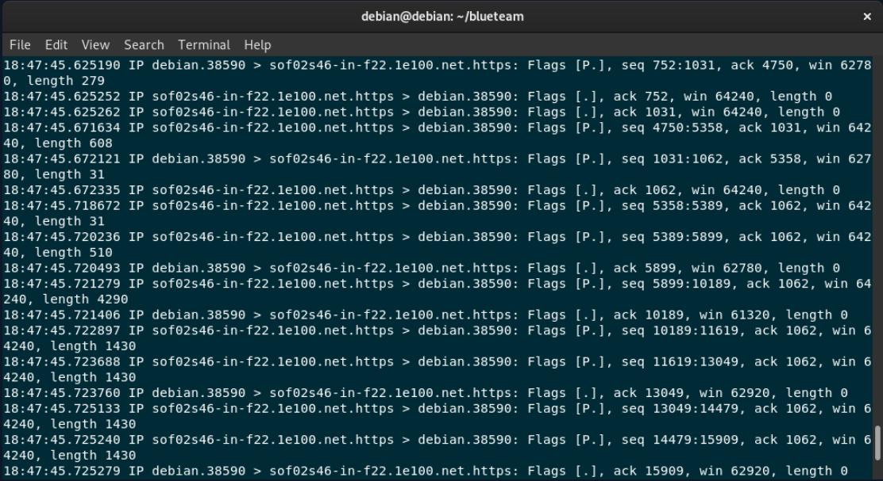

* You can use either “dig *nameOfDomain*” or “nslookup *nameOfDomain*” to find the DNS server IP address for that specific domain (which allows for easier access through the terminal)
* The IP address of the DNS server to which the domain name resolution requests will be sent can be located in the “/etc/resolv.conf”
* The IP addresses to which requests are sent are found in the “/etc/hosts” file
* **This file is very important: If someone messes with the IP addresses, they can easily redirect the requests to their own address and steal any information from it. For example, if you send a request to “google.com” but the IP address to send the request is to a malicious site, then the site will be receive the request (this is very useful for attackers and should be looked at often)**
* You can share files by using the “python -m simpleHTTPServer” command (this can also be used to execute python files”

**Package Management:**

* Red-hat Linux distributions use the RPM (Red-Hat Package Manager) package manager (.rpm) while Debian-based distributions use the APT package manager (.deb)
* The APT package manager has a source list that it uses to download files
* It can be accessed in the “/etc/apt/sources.list” file

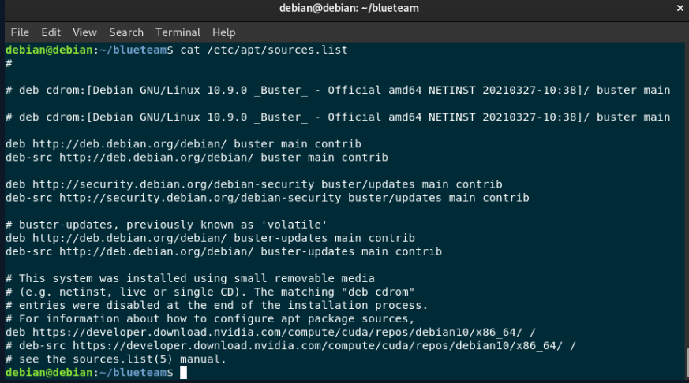

* In order to installed new packages, type “sudo apt-get update”
* To install new versions of existing packages, type “sudo apt-get upgrade”
* You can install an application by typing “sudo apt-get install *nameOfApplication*”
* To see the packages installed on the system, type “sudo dpkg -l”, where -l = long output

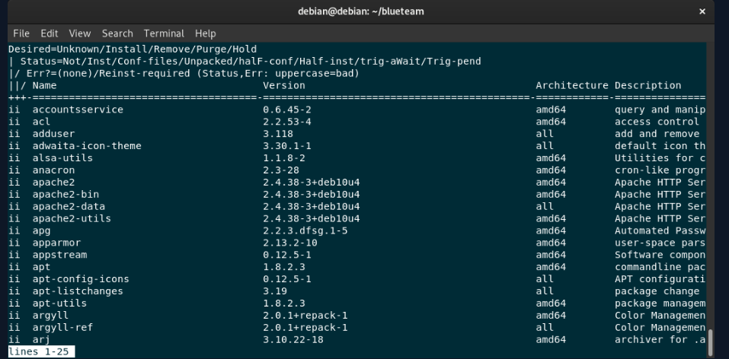

* To remove a package, type “sudo apt-get remove *nameOfApplication*”
* To view information about a package, type “apt show *nameOfApplication*”
* You can install a package (or packages) using dpkg by typing “sudo dpkg -i *nameOfApplication*.deb”, where “-i” = install
* Similarly, you can remove an application by typing “sudo dpkg -r *nameOfApplication*”

**Service Management:**

* Be careful with what services are being run in the background because they can allow access to vulnerabilities in the system
* In order to view all services in the system, type “systemctl list-units --type=service”

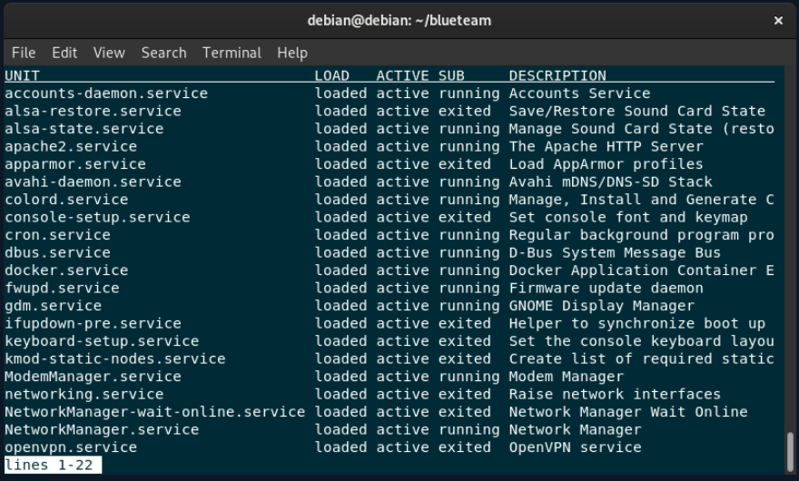

* To list all RUNNING services in the system, type “systemctl list-units --type=service --state=running”
* To show only a specific service, type “systemctl service *nameOfService*”
* You can also stop a service by typing “systemctl stop *nameOfService*”
* To start it up again, type “systemctl start *nameOfService*”

**Scheduled Tasks:**

* Scheduled tasks are called “cron jobs” in linux (because the “cron” service allows for scheduled tasks to run
* To view available scheduled tasks, type “crontab -l”
* “crontab -e” is used for adding, deleting, and changing existing scheduled tasks

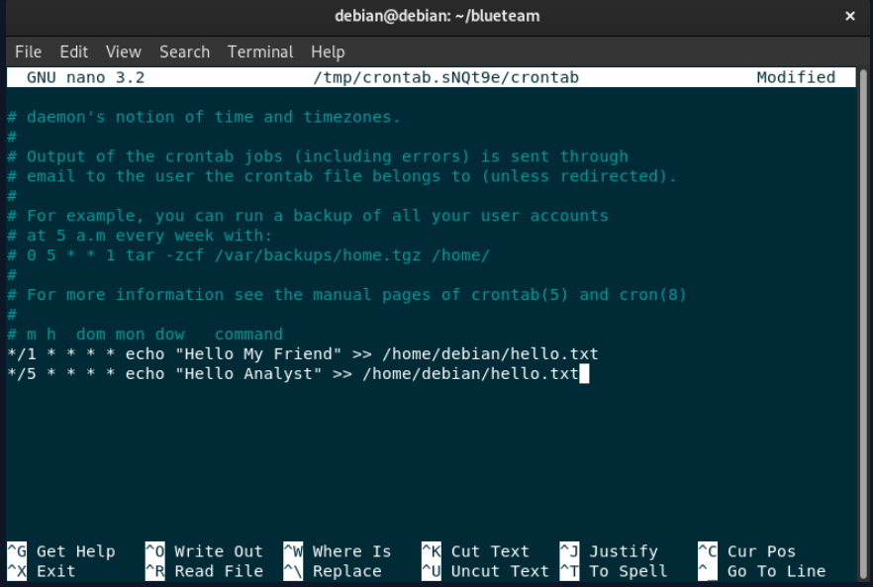

* Format:

1. Minute - (0-59)
2. Hour - (0-23)
3. Day of the month - (1-31)
4. Month - (1-12)
5. Day of the week - (0-7). 0 and 7 are denoted as Sunday

* You can save your changes by clicking CTRL + O

# SOC Fundamentals:

**Introduction and SOC Types and Roles:**

* A SOC (Security Operation Center) is a facility where the information security team constantly monitors and analyzes the security of an organization
* Types of SOC models:

1. In-house SOC- An enterprise’s own cybersecurity team
2. Virtual SOC- The security team often works remotely
3. Co-managed SOC- Internal SOC personnel working with an external Managed Security Service Provider (MSSP)
4. Command SOC- Senior SOCs; Oversees smaller SOCs (Ex: Major telecom companies and defense agencies

* SOC Positions:

1. SOC Analyst- Divided into levels 1, 2, and 3; Classifies alerts, looks for the cause, and advises on remedial actions
2. Incident Responders- Takes part in the threat detection; performs the initial assessment of security breaches
3. Threat Hunter- Finds vulnerabilities before the attacker can exploit them
4. Security Engineer- Maintains the security infrastructure of SIEM (Security Information and Event Management) solutions and SOC products

* Ex: This person is responsible for setting up the connection between SIEM and SOAR (Security Orchestration, Automation, and Response)

1. SOC Manager- Takes on management responsibilities (such as budgeting, strategizing, managing personnel and coordinating operations)

* This position does not deal with technical positions (only operational ones)

**SOC Analyst and Their Responsibilities:**

* A SOC analyst is the first person to investigate incidents and passes it to the his seniors so they can eliminate the potential threats
* They will generally examine alerts on the SIEM and determine which ones are real threats to the system (they do this by utilizing security products such as EDR (Endpoint Detection and Response), Log Management, and SOAR)
* SOC Analysts must:

1. Determine which services, processes, etc. are harmless and harmful to the system (whether it’s Windows, Linux, or other operating systems)
2. Examine the network to see if there are any potential data leaks, suspicious packets being sent/received, or malicious IP addresses or URLs
3. Detect malicious software/files to prevent malware from spreading

* In order to do this properly, they must determine the malicious file’s command and control center and whether or not there is a device communicating with the address)

**SEIM and Analyst Relationship:**

* SEIM (Security Information and Event Management) is a security solution that provides real time logging of events in a particular environment (this is very important because it detects security threats and/or unusual behavior on the system)
* It also filters the data that SOC analysts can collect and create alerts for anything suspicious that may occur

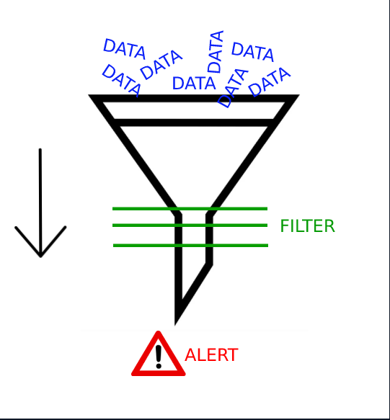

* The SOC analyst must determine if, if an alert goes off, it is a real threat or just a false alarm
* Ex of investigation page:

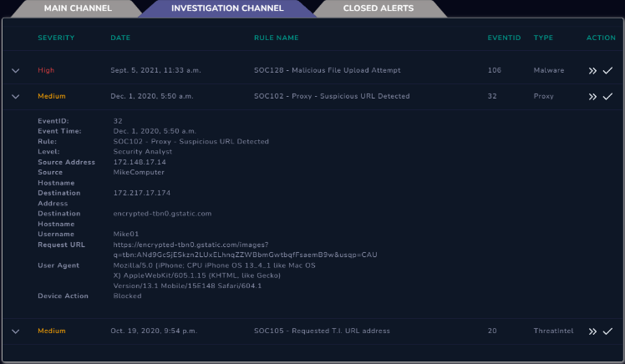

* When you click on an alert, you can view details such as the hostname, IP address, file hash information, etc.) required to successfully determine the risk level of the alert
* Example of false alarm: Alerts whenever the word “union” is in the url (to try and prevent an SQLi attack
* If someone searches “sql union usage” on Google, the alert will sound but there is no real threat
* In this instance, the SOC Analyst now knows to inform their seniors about potential other false alarms that may occur so that they can improve their security

**Log Management:**

* Log management allows a SOC analyst to obtain access to all the logs in an environment (Web logs, operating system logs, firewall, proxy, EDR, etc.) and allows for the management of these logs from a single point
* Example of log manager:

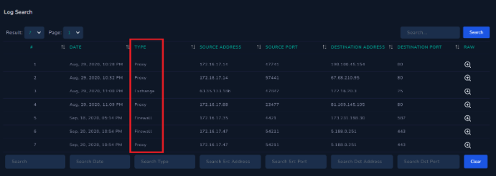

* You can also filter the logs to a particular IP address, URL, etc.

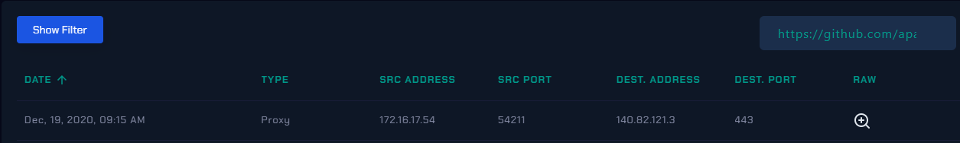

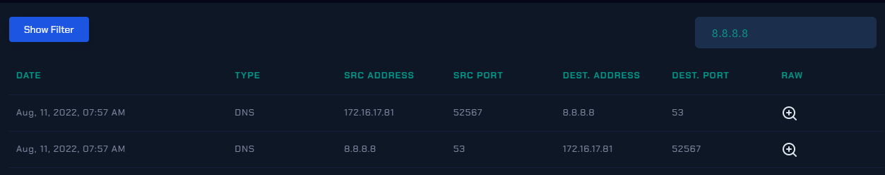

**E(T)DR- Endpoint (Threat) Detection and Response:**

* EDR is a security solution that combines real-time continuous monitoring and collection of endpoint data with rules-based automated response and analysis capabilities
* Examples of EDR solutions: CarbonBlack, SentinelOne, and FireEye HX
* EDR page example:

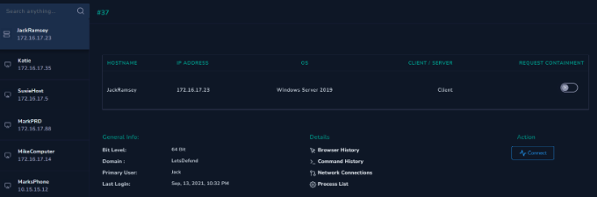

* From here, you can examine things such as browsing history, network connections, and processes running on the system
* You can also access the machine itself by clicking “Connect”
* If you want to stop the attacker’s connection to the inner network in order to prevent their movement, you can isolate a machine be turning on “Request Containment”
* Mshta is an application used to enable an attacker to proxy the execution of arbitrary code through a trusted utility
* Example of command log that contains command to execute Mshta on a host through the “Ps1.hta” utility (Command used: “C:/Windows/System32/mshta.exe C:/Users/roberto/Desktop/Ps1.hta”):

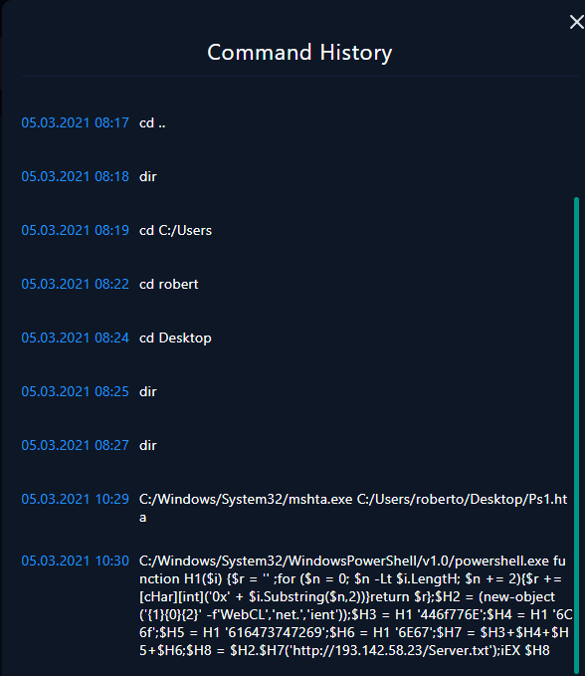

* The difference between a penetration tester and a threat hunter is that pen-testing tells you how an opponent could get into your environment and emphasizes the potential damage of not hardening the environment by showing how different vulnerabilities might be exploited or identifying insecure IT practices while threat hunting tells you who is already in your environment and what they're up to

**SOAR (Security Orchestration Automation and Response):**

* SOAR allows for the security tools used by SOC analysts to work together in order to make the job easier (Examples: Splunk Phantom, IBM Resilient, Logsign, Demisto)

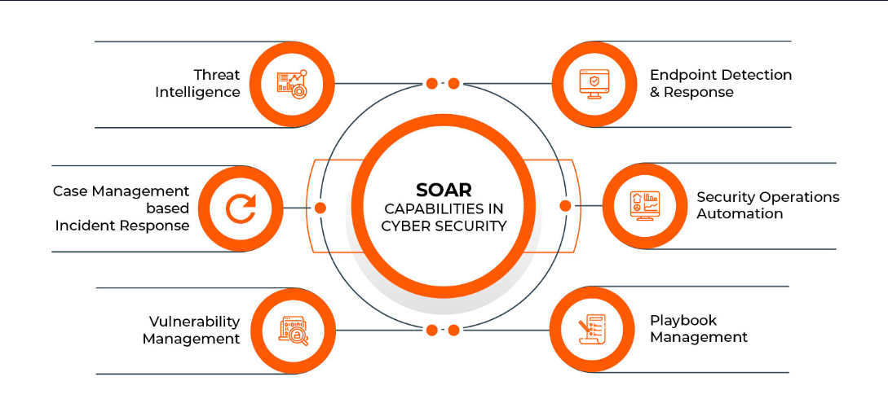

* Frequently used workflows:
* IP address reputation control
* Hash query
* Scanning and acquired file in a sandbox environment
* Centralization general idea:

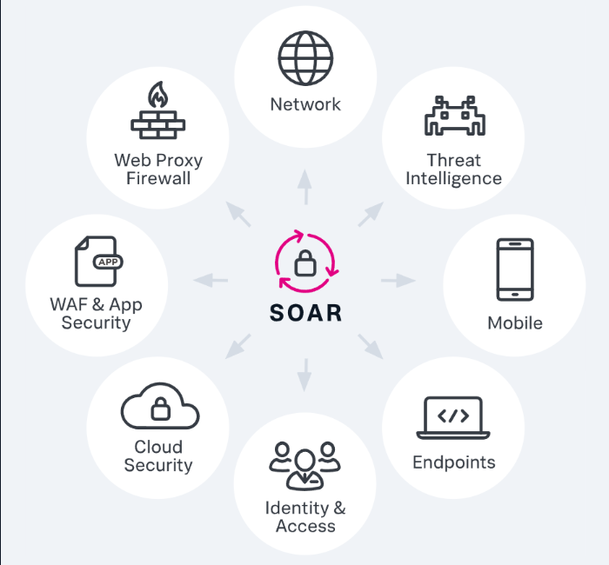

* Access to security tools and platforms in one place

**Threat Intelligence Feed:**

* A threat intelligence feed is data provided by a third party company (such as malware hashes or IP addresses)
* Even if you perform a scan for a potential virus or if the hash of the potential malware you’re testing doesn’t match anything from the database of hashes you’re using, you cannot assume that the malware is clean
* Since IP addresses change and other people can be the owner of that IP that wasn’t the ORIGINAL owner, we cannot assume that an IP address always contains the (possible) harmful malware it did in the past

**Common Mistakes for SOC Analysts:**

1. Overly depending on VirusTotal results- Just because the results are “clear” doesn’t mean it’s actually clear

* The attacker could have used an antivirus bypass technique in order to make the SOC analyst believe that there is not actually a virus contained in the URL, file, or whatever is being uploaded

1. Hasty analysis of malware in a sandbox – Sometimes malware will not activate in a sandbox environment until about 10-15 minutes after it is open

* There is also the case where the malware detects the sandbox environment; in this case, it will not activate

1. Insufficient log analysis – If a log analysis is not performed correctly, then the malware could easily slip out of the SOC analyst’s sight and could potential harm several other hosts
2. Overlooking VirusTotal dates – If a URL/file/etc. was already searched before, a cache is written in the VirusTotal website; in this instance, it’s best to look at the “Last Updated” column because since the last search, malware could have been placed within the link (so what you assume is a clean website now contains unsuspecting, harmful malware)

# Network Fundamentals 1:

**Introduction to Network Fundamentals:**

* Computer network- The structure in which at least two devices communicate with each other
* Main purpose of computer networks:

1. Providing image and sound transfer
2. Hardware sharing (printers)
3. File, data, and information sharing
4. Software sharing
5. Central management
6. Support

* The Advanced Research Projects Agency Network (ARPANET) is a computer network that is considered to be the foundation of the internet as a whole

**Type of Networks:**

* Personal Area Network (PAN)- Networks with a minimal and small number of devices that cover a very short distance (Example: Wireless headphones connected to a phone, laptop, or both)
* Local Area Network (LAN)- Most common network type; Geographically spread over a wider area (Example: home networks or shared networks within the same building)
* LANs have a much larger area than PANs and supports much more than 2 decives in terms of capacity
* Metropolitan Area Network (MAN)- City-sized computer network; consists of many LAN computer networks interconnected with each other
* Connects networks using fiber optic cabling

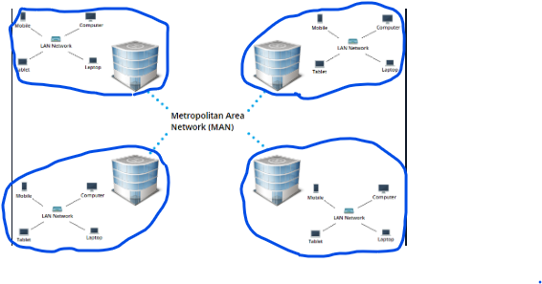

* Wide Area Network (WAN)- The Internet is a good example of this kind of network
* A WAN can span throughout continents and has the largest geographical area when compared to other computer networks
* Also connected through intercontinental fiber-optic infrastructures
* Campus Area Network (CAN)- Can consists of several LANs and is usually a part of universities, institutions, or private companies
* Geographically smaller than MANs but larger than LANs

**Network Topologies:**

* Two types of the network topology:

1. Physical topology- All devices and components in the network are drawn in terms of their exact locations (Example, a router connecting device A to device B)
2. Logical topology- The path of the data flow that is desired to be emphasized rather than the physical placement of the devices

* Ring topology:
* Close logic loop; Sent data travels around the ring in one direction until it reaches the destination
* There is no hierarchical relationship between nodes

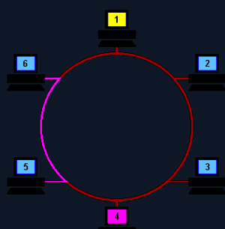

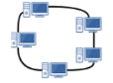

* Advantages:

1. Performs better than bus topology in heavy data traffic
2. Does not need a central node
3. Is easy to install and configure as it only requires 2 connection changes to add a new node
4. Error checking and repair can be done easily because of its point-to-point structure

* Disadvantages:

1. The entire network is adversely affected when there is a node that does not transmit
2. If nodes are added or migrated, the whole network can be adversely affected
3. The transmission delay in the network increases in direct proportion to the number of nodes
4. Bandwidth is shared across all connections between devices

* Star topology:
* One of the most common topologies
* Each node is connected to a central node
* Data flow 🡪 Central node
* Advantages:

1. One or more nodes can be disconnected without other nodes being affected
2. The network still operations the same if a new node is added or if an existed node is deleted
3. Provides good network performance under heavy traffic
4. Suitable for large networks with multiple devices

* Disadvantages:

1. High cost because of cabling at each node
2. If central node fails, all nodes fail and the connection is broken

* Mesh topology- No central node and each node is directly connected to each other
* Two types:

1. Full-Mesh:

* Each node is connected separately by cabling (so there are multiple ways to connect)

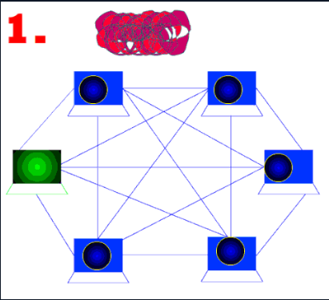

1. Partial-Mesh:

* Nodes aren’t all connected to each other but are largely interconnected

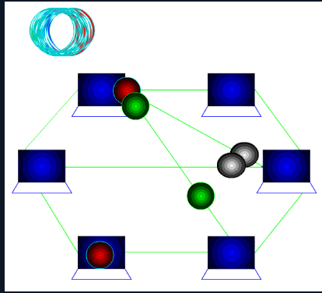

* Bus topology- Nodes are located on a common path and data transmission is made with a bidirectional connection
* Each node receives all transmitted data (Even if it doesn’t belong to them)
* Advantages:

1. Easy to add nodes
2. Good for small networks
3. Easy to extend the bus
4. Uses one cable (low cost)

* Disadvantages:

1. High probability of packet loss
2. Bandwidth is shared so performance may suffer
3. High rate of being affected by network errors
4. If there is a break in the main transmission cable, the network splits in two and problems with packet transmission will occur

* Point-to-Point topology- Consists of two nodes connected together (direct connection between hosts)
* This is the simplest topology
* Tree topology- Connects star and bus topology in a hierarchal order (bus on top and star underneath)
* There can be any number of busses and subnodes

**OSI Reference Model:**

* OSI = Open Systems Interconnection
* Layers of the OSI model (ascending order):

1. Physical layer- Responsible for the transmission of data (ordered bit sequences) through communication channels
2. Datalink layer- Processes the bits from the physical layer and prepares them to be sent to the next layer

* This layer is the first layer responsible for error checking
* This layer contains the ATM, Token Ring, Frame Relay, and Ethernet protocols

1. Network layer- Delivers the data to the destination IP
2. Transport layer- Transmission security; Provides additional controls for error-free transmission of data
3. Session layer- Provides the necessary services for the presentation layer to work
4. Presentation layer- Displays data

* Two communicating nodes must use a common language for data representation

1. Application layer- Provides access to structures found in the user-level

* This layer is the closest to the user when compared to the others
* FTP, HTTP, and SMTP are all a part of this layer

**Network Devices:**

* Switch- Used to connect nodes that want to connect to the network; transmits data from the source port only to the destination port (does not affect network performance) and prevents data belonging to two parties from reaching third parties
* Isolates data transmissions to specific devices
* Connects several devices
* Layer 2 (Datalink); Some can operate at the level 3 (Network) layer as well
* Router- Packet routing device; Often used in LAN-LAN or WAN-LAN connections
* Provides segmentation of networks
* Contains an OS (Cisco IOS (Internetwork Operating System) or other firmware for home routers)
* Layer 3 (Transport)
* Hub- Connects computers that want to connect to the network; acts as a broadcaster when it comes to data transmission from one port to all other ports in the network (transmits through electrical signals)
* Do not perform packet filtering or addressing functions
* The difference between a hub and a router is that a router sends data in the form of a packet and uses the IP address for data transmissions
* Best suited for simple LAN environments
* Layer 1 (Physical)
* Repeater- Contains only 2 ports that transforms the incoming signal into an outgoing signal and transmits it to the destination; Strengthens the weak signals on it and enables it to transmit data to longer distances
* Repeaters are similar to a hub but do not have as many ports and regenerates the input data
* Monitors the signals that are created between two LANs
* Layer 1 (Physical)
* Bridge- Performs packet routing by connecting two computer networks
* The only differences between a bridge and a router is that a bridge has less ports and works in layer 2 rather than layer 3
* Can be used in LAN-to-LAN connections
* Layer 2 (Datalink)
* Modem- Generally used in small home networks to access the internet
* Includes one or more ports and a small OS
* If you only had one device that needs to be connected via Ethernet, you can directly connect it to the modem (then there’d by no need for a router)
* It’s possible to provide an internet connection by using wireless devices together with a modem
* Layer 2 (Datalink)
* Firewall- Ensures the security of the network by blocking and allowing traffic (based on a set of rules)
* Most common type: hardware network firewall devices
* Types of network firewalls:

1. Hardware firewalls
2. Software firewalls
3. Cloud firewalls (Network and Transport layers)
4. Packet filtering firewalls
5. Circuit-level gateways (Session layer)- Monitor TCP handshaking between packets to determine whether or not the session is legitimate
6. Stateful inspection firewalls (Network and Transport layers)- Individually tracks sessions of network connections traversing it
7. Proxy service application firewalls/Gateway firewalls (Application layer)- Limits the applications that a network can support; prevents networks from directly contacting other systems

* Contains its own IP address (so an external network connection cannot receive packets directly from the network)

1. Next-generation firewalls (Application layer)- Combines traditional firewall capabilities (such as packet filtering and stateful inspection) with others to make better decisions about what traffic to allow; filters packets based on applications

* If the firewall is not configured correctly, your network can be subject to major outside threats

Layers 3 (Network), 4 (Transport), and 7 (Application)

* Gateway- Provides inter-network communication between two networks (connects networks)
* There are both hardware and software gateway types
* Nodes can go out of the network and communicate with nodes from other networks because of this device
* Works at every layer

**TCP/IP Model:**

* There are 4 layers to the TCP/IP model:

1. Network Access Layer- Includes physical access and hardware controls/infrastructure (Ethernet cables, wireless networks, NICs (Network Interface Cards, etc.)

* Layers 1 (Physical) and 2 (Datalink) in the OSI model

1. Internet Layer- Performs network communication functions through logical addressing; controls the flow and routing of traffic to ensure a fast and accurate delivery

* Reassembles the data packet at the destination
* Layer 3 (Network) in the OSI model

1. Transport Layer- Performs data transmission and ensures a reliable connection through ACKs

* Layer 4 (Transport) in the OSI model

1. Application Layer- Allows the user to access the network (emails, social media, cloud storage, etc.)

* Layers 5 (Session), 6 (Presentation), and 7 (Application)
* The TCP/IP model can also be separated into 5 layers rather than 4:

1. Physical
2. Datalink
3. Network/Internet
4. Transport
5. Application

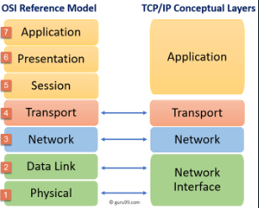

**IP Addressing Mechanism:**

* IPv4:
* 32-bits
* Decimal notation (Ex: 192.168.10.1)
* 232 addresses
* IP to binary:

10.5.37.156 = 10 🡪 00001010

5 🡪 00000101

37 🡪 00100101

156 🡪 10011100

* (00000000)2 = (0)10
* (11111111)2 = 1 + 2 + 4 + 8 + 16 + 32 + 64 + 128 = (255)10
* IP classes (determined by byte 1/first 8 bits in IP address):

1. Internetwork communication (3 classes):

* 0-127
* 128-191
* 192-223

1. Multicasting:

* 224-239

1. Research and experiments:

* 240-254
* You can determine the network the device with he IP address is included in using the remaining bits:

|  |  |  |  |  |
| --- | --- | --- | --- | --- |
|  | 8 bits | 8 bits | 8 bits | 8 bits |
| 1a | Network | Host | Host | Host |
| 1b | Network | Network | Host | Host |
| 1c | Network | Network | Network | Host |

* IP addresses with the same first 1, 2, or 3 (depending on the class) bytes belong to the same network
* IPv6:
* 128-bits
* Hexadecimal notation
* 2128 number of addresses
* Private networks- Networks that aren’t directly connected to the internet; connected through an intermediary network device (Ex: home networks through a modem)
* Private address space:
* 10.0.0.0 - 10.255.255.255
* 172.16.0.0 – 172.31.255.255
* 192.168.0.0 – 192.168.255.255
* Local host/loopback address space:
* 127.0.0.1 – 127.255.255.255
* A subnet mask is a 32-bit number that shows which bits belong to the network (1s) and which ones belong to the host (0s)

**Network Address Translation (NAT):**

* NAT converts private IP addresses to public IP addresses (Ex: 10.6.1.2:2031 🡪 171.69.68.10:2031)
* This is useful because it allows for local communication within a LAN
* NAT uses a NAT table to convert IP addresses as packets are being routed
* Advantages of NAT:

1. Slows down the exhaustion of IPv4 addresses
2. Less likely for there to be conflict with IP addresses
3. Flexible connection setup

* Disadvantages of NAT:

1. Reduced end-to-end traceability
2. Not compatible with every application
3. Might cause delay

# Network Protocols:

**Transmission Control Protocol (TCP) – 1:**

* Transmission Control Protocol (TCP)- A network protocol that provides reliable and steady data transmission between applications
* Located at layer 4 (Transport Layer)
* Slow than User Datagram Protocol (UDP)
* Requires a three-way handshake to establish connections using ACKs and SYNs
* Ensures data transmission (contains an error control)
* Sends data in sequence (so it uses more flow control)
* Allows for multiple connections
* No data transfer before connection is established
* Priority and security definitions can be made for the data sent
* Three-way handshake steps:

1. Sender sends SYN segment to recipient (usually the server)
2. Recipient sends a SYN and ACK segment back to the sender to ensure that the SYN was received
3. Sender sends an ACK segment acknowledging the SYN and ACK segments previously sent and the connection is established

* TCP segments 🡪 Eight-bit data
* Data sending steps:

1. Sender sends a TCP segment containing a piece of the data
2. Recipient sends an ACK acknowledging the received segment
3. Steps 1 and 2 are repeated with the other segments

* The protocol sends a random number during the connection establishment called the Initial Sequence Number (ISN)
* From there, each ACK will contain the previous sequence number + the number of bytes the segment contains to ensure that the data was received
* If the sender doesn’t receive the correct ACK number (or receives nothing at all), it will re-send the previous segment and expect the correct one from the new ACK
* In order to end a TCP connections, there are 4 steps:

1. Whoever wants to end the connection sends a FIN (finish – 1-bit field in the TCP protocol header) segment to the recipient
2. The recipient sends an ACK
3. The recipient sends a FIN right after
4. The original sender sends an ACK and the connection is terminated

* TCP connections can also be ended using the RST (reset) flag and is a one-sided connection termination
* This usually occurs when a segment arrives that does not meet the criteria for a referenced connection and it needs to be shut down immediately
* Each TCP connection consists of “Source IP address-Source Port Number, Destination IP address-Destination Port Number”
* Ports allow applications to communicate with each other and have values between 0 and 65535 (Ex: the default port for HTTP is 80)
* Socket Address example: 192.168.5.100:8080 (IP_address:Port_Number)
* Default ports:
* File Transfer Protocol = 21
* Secure Shell (SSH) = 22
* Telnet = 23
* Simple Mail Transfer Protocol (SMPT) = 25
* Domain Name System (DNS) = 53
* HyperText Transfer Protocol (HTTP) = 80
* Post Office Protocol 3 = 110
* Server Message Block (SMB) = 445
* Ex:

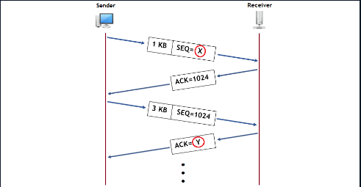

X = 0

Y = 1024 + 1024 * 3 = 4096

**Transmission Control Protocol (TCP) - 2:**

* Header and fields for TCP:

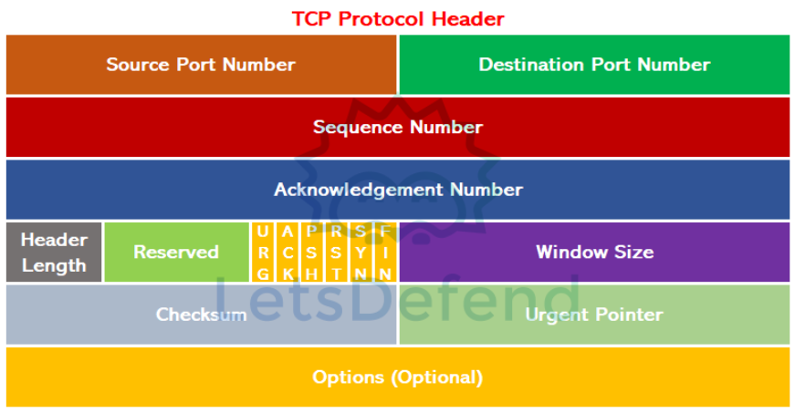

* Source port number = 16 bits
* Destination port number = 16 bits
* Sequence number = 32 bits; if the segment contains the SYN flag, the value is the initial sequence number
* Acknowledgement number = 32 bits; indicates up to which byte the transmission of the sent segments is made
* Header Length (HLEN) = 4 bits
* Reserved = 3 bits
* Control flags = 9 bits; all bits are set to 0 until one flag is needed (that one bit is then set to 1)

Flags:

1. SYN
2. ACK
3. FIN
4. RST
5. PSH (push)- Instructs the OS to send and receive the entire content of data immediately
6. URG (urgent)- Notifies that the data is urgent and should take priority

* Window Size – 16 bits; defines maximum buffer capacity
* Checksum = 16 bits (hexadecimal); represents the number of bits in a transmission message to detect high-level errors within data transmission
* Urgent pointer = 16 bits; indicates up to which data the urgent bytes are
* Options = No fixed length; used to indicate additional features
* Netcat (used through the Linux command “nc”)can be used to establish a TCP connection between devices
* Example command = “sudo nc -lvp 5555”, where flags l = listen mode, v = verbose, and p = port
* From the other system, the command “sudo nc 192.168.216.128 5555” can be used to establish the connection
* Wireshark can be used to examine TCP segments in detail
* Ex:

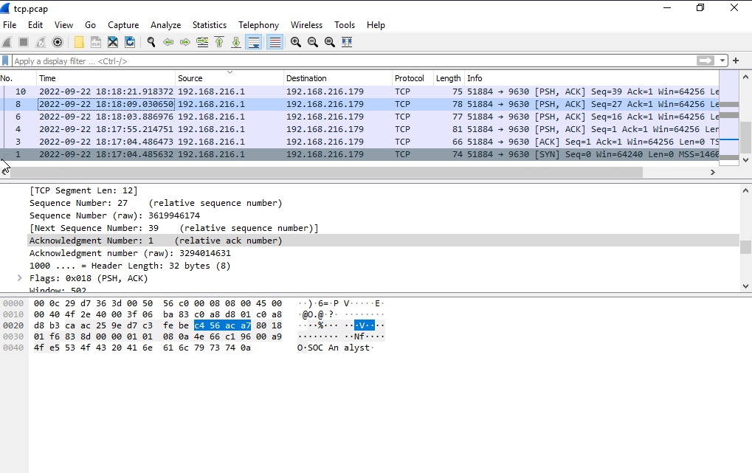

**User Datagram Protocol (UDP):**

* Located in the 4th (transport) layer of the OSI model
* Features:

1. No connection setup (no three-way handshake like TCP)
2. Fast transmission
3. Does not guarantee data delivery
4. Contains less information in the header structure
5. Often used by video and real-time applications
6. No error checking
7. No flow control

* Some other default ports:
* DNS- 53
* DHCP- 67, 68
* SNMP- 161, 162
* UDP headers:

1. Source port number- 16 bits
2. Destination port number- 16 bits
3. Length- 16 bits
4. Checksum (not required as opposed to TCP)- 16 bits

* UDP in Wireshark:

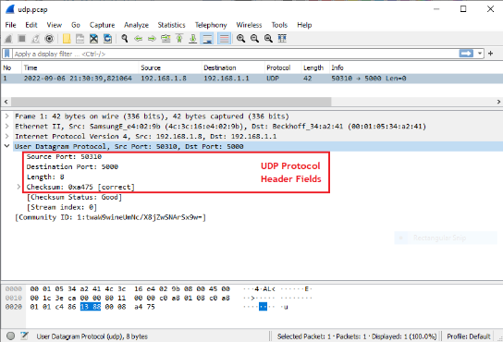

**Domain Name System (DNS) - 1:**

* The DNS is used to match hostnames (domains) to their corresponding IP addresses so host can reach them easier
* Domain- An address used to access websites (Ex: app.letsdefend.io)
* Subdomain- sub-sites under the main domain (Ex: app.letsdefend.io)
* Top-Level domains- Extensions added to the domain names (Ex: .com, .net, .gov, .edu, etc.)
* DNS features:
* 7th (application) layer
* Uses UDP
* Hierarchical structure
* Uses distributed databases
* Each organization has its own DNS server
* If the domain is not found in the local DNS server, it will contact the “Root DNS server” to detect the authorized DNS server of that domain name
* Some types of DNS records:

1. A- Address Record (IPv4)
2. AAAA- Address Record (IPv6)
3. CNAME- Canonical Name Record
4. MX- Mail Exchange Record
5. NS- Nameserver Record
6. PTR- Pointer Record
7. SOA- State of Authority Record
8. SRV- Service Location Record
9. TXT- Text Record

* DNS in Wireshark:

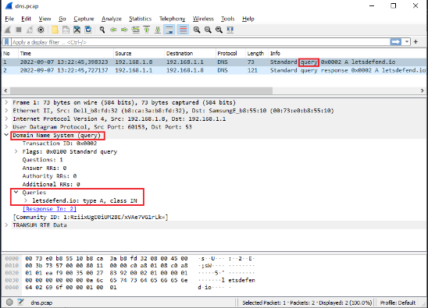

**Domain Name System (DNS) - 2:**

* When a DNS query is made, it checks the /etc/hosts file first to check if the record is valid
* The “dig” command allows you to make DNS queries from the Linux command line
* You can also use “nslookup” in both Windows and Linux to perform DNS queries

**Telnet (Teletype Network) Protocol):**

* Telnet allows you to access devices through the command line
* 7th (application) layer of the OSI model
* Uses TCP (port 23)
* Usually used for management purposes
* Not preferred because it transmits the data traffic without encryption
* If you want to use telnet on Windows, you need to install and activate a telnet client using the control panel (example command:”telnet 192.168.5.100”)

# Detecting Web Attacks:

**Introduction – Why Detecting Web Attacks is Important:**

* Common web attacks:

1. SQL Injection (SQLi)
2. Cross Site Scripting (XSS)
3. Command Injection
4. Indirect Object Reference (IDOR)
5. RFI and LFI
6. File Upload (Web shell)

* Open Web Security Application Project (OWASP) top 10 list contains the most common web exploits
* OWASP Zap is an application used to help scan for vulnerabilities in web applications
* OWASP Juice Shop is a vulnerable web application project (written with Node.js) in order for security researchers to improve themselves

**How Web Applications Work:**

* HTTP Request message example:

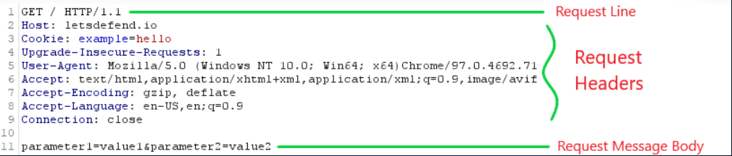

* The resource ‘/’ is requested using a GET request (since it’s not a link, it’s requesting the server’s main page
* Host = Indicates which domain to locate (since there are often times more than one)
* Cookie = Stores session information; An example would be SESSIONID=123456789
* Upgrade-Insecure-Requests = Indicates that the client wants to communicate with encryption (SSL)
* User-Agent = Contains information about the user’s browser and OS; Sometimes, you can find automatic vulnerability scanners
* Accept =Accepts only those specific types of data
* Connection = Shows how the HTTP request will be made; “Close” means the TCP connection will close once the response is received and “Keep-Alive” means the connection will continue
* There is an empty line indicating a partition in between the headers and the message body
* If the POST method is used instead of GET, then those headers will be found here instead (same with HEAD, PUT, etc.)
* HTTP Response Example:

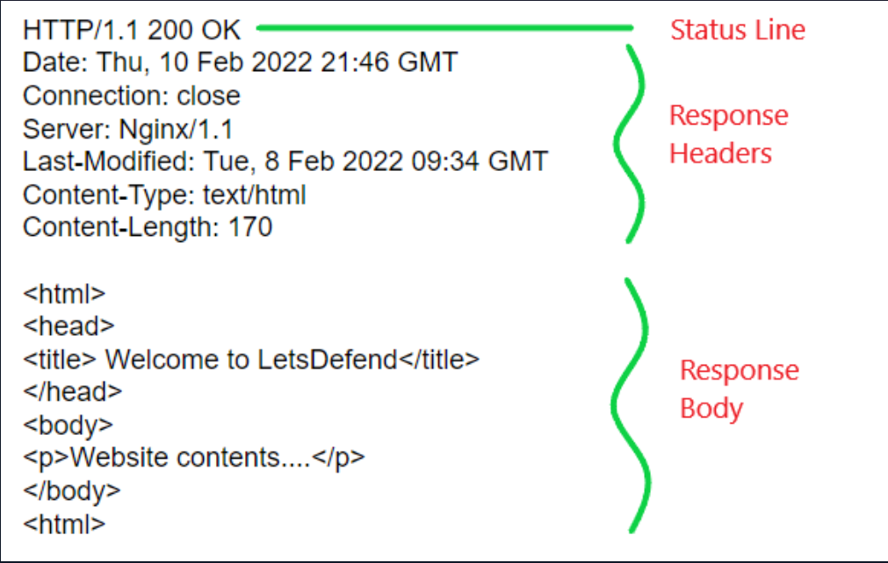

* Status codes (In general):

1. 100-199 = Informational Response
2. 200-299 = Successful Response
3. 300-399 = Redirection Message
4. 400-499 = Client Error Response
5. 500-599 = Server Error Response

* Response Headers:

1. Date = The exact time the HTTP response was sent to the client
2. Connection = States how the connection will be handled
3. Server = Provides information about the server’s OS and web server’s version
4. Last-Modified = Provides information about the last time the requested resource was modified; This is used for cache purposes
5. Content-Type = Shows the type of data being sent
6. Content-Length = Shows the size of the data sent in bytes

* The POST method ensures that the submitted parameters do not appear in the requested URL

**Detecting SQL Injection Attacks:**

* SQLi -Inserting malicious SQL queries in order to exploit a vulnerability in a web application; An example of this kind of attack would be ’ OR 1=1
* There are three types of SQL injections:

1. In-Band SQLi/Classical SQLi: The SQL queries is sent and replied to within the same channel
2. Inferential SQLi/Bling SQLi: SQL queries that receive a reply that cannot be seen
3. Out-Of-Band SQLi: The SQL queries are sent and replied to over a different channel; An example of this would be if the attacker is receiving replies over the DNS

* You can enter a payload such as ‘ OR 1=1 -- - in order to make the password field a comment (since -- - comments the rest of the line in SQL)
* In order to prevent SQLi attacks, you can:

1. Use a framework and keep it up to date
2. Always sanitize data from a user
3. Avoid using raw SQL queries

* To protect against SQLi attacks:

1. Examine all areas that come from the user when looking at a web request
2. Look for SQL keywords such as INSERT or SELECT
3. Check for special characters such as ‘ or -
4. Familiarize yourself with common SQLi payloads

* In order to detect SQLi devices, you can:

1. Look at the User-Agent header
2. Check the frequency of requests
3. Look at the contents of the payload
4. Check if the payload is complicated

* Access logs example:

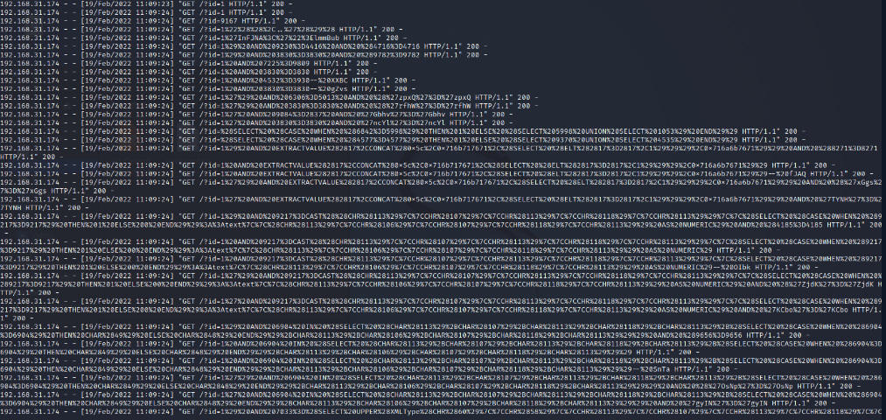

* When placing it in a decoder:

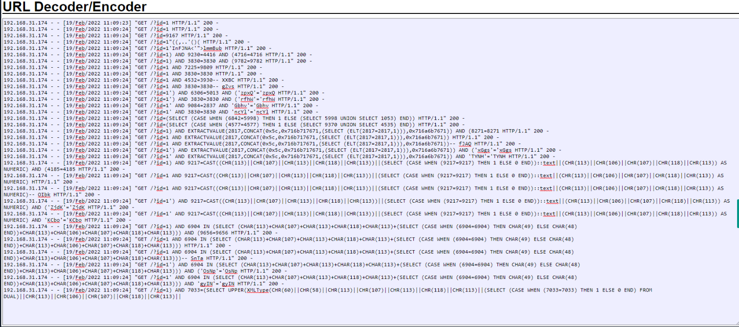

* You can tell whether the SQLi attack was successful or not by looking at the response size (since you will not have access to the response itself when analyzing)

**Detecting Cross-Site Scripting (XSS) Attacks:**

* Three types of XSS attacks:

1. Reflected XSS (Non-Persistent) – A malicious script is reflected off of a web application to the victim’s browser; Activated through a link
2. Stored XSS (Persistent) – The attacker can permanently upload the XSS payload to the web application; Relies on unsanitized user input points

* This is the most dangerous type of XSS attack

1. DOM Based XSS – The attack is executed as a result of modifying the Document Object Model (DOM) environment in the victim’s browser used by the original client side script so that the script can run in an “unexpected” manner

* Example of an XSS attack: <p>Hello <?php echo $_GET[‘user’]; ?>.</p>
* In the URL, you can type “?user=<script>alert(“HACKED”)</script>” at the end in order for the attack to successfully execute (a pop-up will show up on the page)
* In order to redirect a user to another site (for example, a malicious one), you can use:

“?user=<script>window.location=”*URL*”</script>”

* You can also document the user’s cookies by typing:

“?user=<script>document.cookie</script>”

or

“?user=<script>prompt(document.cookie)</script>”

* Another common XSS payload is “console.log” which displays the console logs from the current page
* An XSS attack can be prevented by:

1. Sanitizing incoming user data
2. Using a framework (and making sure it’s used correctly)
3. Keeping your framework up to date

* You can detect an XSS attack by:

1. Looking for keywords
2. Familiarizing yourself with frequently used XSS payloads
3. Check for any special characters such as “<” and “>”

* If you see JavaScript, keep in mind that there may be an XSS attack occurring
* Example of access logs showing an XSS attack:

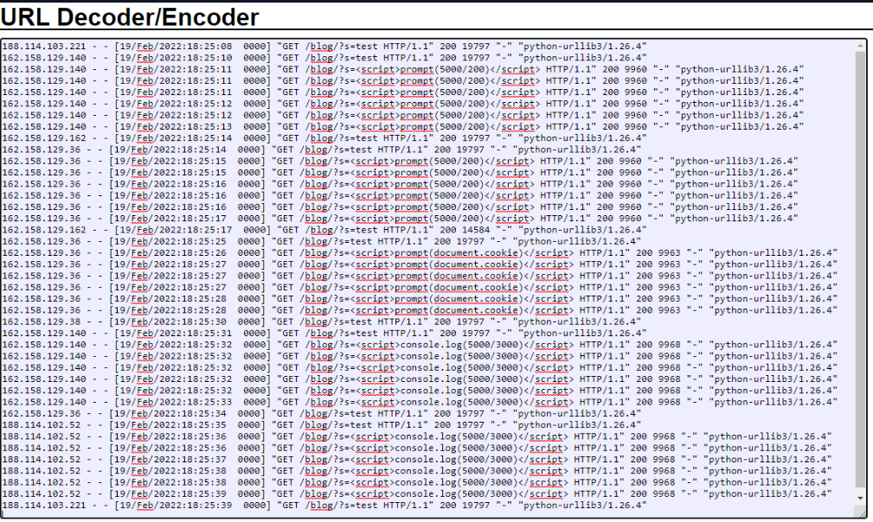

* You can determine if an XSS attack was successful by looking at the response in the logs

**Detecting Command Injection Attacks:**

* Command Injection Attacks – Occurs when received data from the user is sent directly to the OS shell without being sanitized
* This is used to execute unauthorized commands on the OS
* Ex: If the code for the web application is:

<?php

$file_name = $_POST[‘file_name’]

$output = shell_exec(‘cp $file_name /tmp/’);

//This code takes a file input from the user and copies it to the /tmp/ directory

?>

The user can input a file named “letsdefend;shutdown;.txt” in order to run the commands “letsdefend”, “shutdown”, and “.txt”, resulting in the OS shutting down successfully

* The attacker can create a reverse shell on the victim’s OS through a specific payload
* Information on reverse shells: <https://www.imperva.com/learn/application-security/reverse-shell/>
* To prevent a command injection, you should:

1. Always sanitize user data
2. Limit user rights
3. Use virtualization technology such as dockers

* To detect CLI attacks:

1. Look at all the areas when examining a web request
2. Look for commands or anything else that may resemble terminal language
3. Familiarize yourself with common CLI payloads

* A good example of a CLI attack is Shellshock in which bash involuntarily executed Environment Variables in an HTTP request:

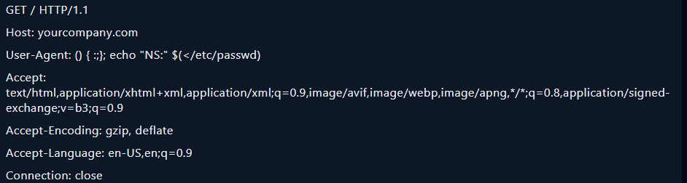

* When the command runs, the contents of /etc/psswd will be shown and the HTTP response header will be “NS”
* Example of CLI attack:

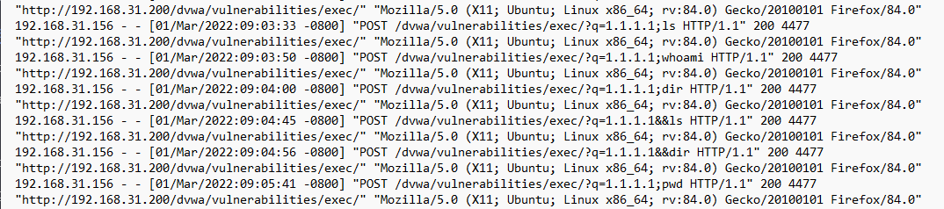

**Detecting Insecure Direct Object Reference (IDOR) Attacks:**

* An IDOR attack occurs when an attacker manipulates the parameters sent to a web application and gains access to (an) object(s) that do not belong to them
* Ex: https://examplelogin.com/index.php?id=10
* If this attack worked, the attacker would have access to the user account with id 10 and can view all the associated information
* If the attacker successfully implements an IDOR attack, they can:

1. Steal personal information
2. Access unauthorized documents
3. Conduct unauthorized processes

* One of the ways to prevent this kind of attack is to remove parameters entirely and verify through session information (ex: SESSONID)
* To identify IDOR attacks:

1. Check all parameters
2. Look at the request count made for the page
3. Search for any pattern in the parameters

* Wfuzz is a device that is used to automate web application security assessments by finding any vulnerabilities
* <https://wfuzz.readthedocs.io/en/latest/>

**Detecting RFI and LFI Attacks:**

* Local File Inclusion (LFI) is an attack that occurs when a file is included without sanitizing user data; the file is included on the same web server that the web application is hosted on
* Remote File Inclusion (RFI) is an attack that occurs when a file is included without sanitizing user data; the file is hosted on a different server as opposed to on the same web application
* LFI and RFI vulnerabilities are caused by the use of data received from a user directly in the system or by a file included on a remote server
* Ex: A web application takes a “language” parameter in order to determine what language the page should display in (an example would be “en” for English). If the user enters the payload “/../../../../../../../../../etc/passwd%00” (“%0” is meant to end the string) , the website will display the information for the “/etc/passwd” file.
* Using LFI and RFI attacks, attackers can perform code execution and denial of service attacks and disclose sensitive information
* To prevent LFI and RFI attacks, you should ensure that any received data is sanitized and the controls are properly set on both the client-side and server-side.
* To detect an LFI and RFI attack:

1. Examine all fields when looking through web requests
2. Check for special characters such as ‘/’ and ‘.’
3. Familiarize yourself with commonly used LFI files
4. Search for acronyms such as HTTP and HTTPS to detect RFI attacks (because attackers usually send files over their own web server)

# Malware Analysis Fundamentals

**How Malware Analysis Helps SOC Analysts:**

* Stuxnet procedure (targeting Siemens AG’s industrial control system):

1. Infection – Begins infecting a system through a USB stick and spreads to any other machine running Microsoft Windows

* The worm is able to move undetected through a false digital certificate

1. Search – The malware then checks whether a machine is part of the targeted industrial control system
2. Update – Not a target = Ignore; Target = Worm attempts to connect to the internet and download a newer version of itself
3. Compromise – Worm compromises the system’s logic controllers and begins exploiting “zero day” vulnerabilities
4. Control – The malware spies on the operations of the system and uses the information to take control of the centrifuges, making them spin themselves to failure
5. Deceive and Destroy – While this is happening, false feedback is being provided to outside controllers so they will not know what is happening until it is too late.

**Malware Definition and Malware Types:**

* Malware (Malicious Software) – Any software that endangers the security and integrity of systems by targeting a malicious purpose
* Common types of malware:

1. Backdoor – Leaving a backdoor on the device where the malware is installed, attackers can access the system and exploit it
2. Adware – Causes unwanted advertisements to display on the device (usually occurs with downloaded software)
3. Ransomware – Demands ransom from people by encrypting and exfiltrating all files on the device
4. Virus – Contains a self-replicate feature and provides persistence by infecting other files on the device
5. Worm – Spreads from infected devices to other devices

* The Morris Worm was the first worm malware to spread to the internet

1. Rootkit – Disguises itself by providing access to a high level of authority on the device
2. Remote Access Trojan (RAT) – Targets banking applications and causes money to be stolen
3. Keylogger – Logs pushed keys and sends the information to the attacker

* The ransomware attack “WannaCry” took advantage of a recently disclosed Microsoft vulnerability (MS17-010 – “Eternalblue”) associated with the Shadow Brokers tool release
* Sunburst was the name of the malware that was detected in December 2021 and distributed through the SolarWinds Orion product and caused the hacking of many organizations such as FireEye

**What Should a Malware Analyst Know:**

* A malware analyst should be familiar with:

1. Operating System Fundamentals and Architecture
2. Assembly Language and Programming
3. Network Protocols and Fundamentals
4. Cryptography

* Ransomware uses asymmetric encryption; using a public-private key relationship, this form of encryption allows only the attacker to decrypt the encrypted files using their private key
* Advanced Encryption Standard (AES) encryption is typically used by ransomware-type malware

**Which Approach Should You Choose When Analyzing Malware?:**

* There are two malware analysis approaches:

1. Static analysis- Analyzing malicious software by reverse engineering methods without running them (decomposing/disassembling the malware)

* Information Examined:

Portable executable headers

Imported DLL’s

Exported DLL’s

String in binary

CPU instructions

1. Dynamic analysis- Examines the behavior of malicious software by running it

* Examine:

Network Connections

File Events

Process Events

Registry Events

* Static Analysis: Dynamic Analysis:

Takes a long time Takes a short while (in general)

You can learn the capacity of the malware You can learn only the activities on the system on which it runs

Detailed analysis result Analysis result is not detailed

**Dynamic Analysis Example Using AnyRun:**

* AnyRun is an interactive sandbox used to quickly analyze malware
* You can choose the operating system you want to run the malware on and AnyRun will create a VM executing the malware
* The application allows you to view the:

1. OS
2. Process list
3. Network and file events
4. Process details

* You are also able to view the threat score of individual processes running from the malware and what dangers they have on the system

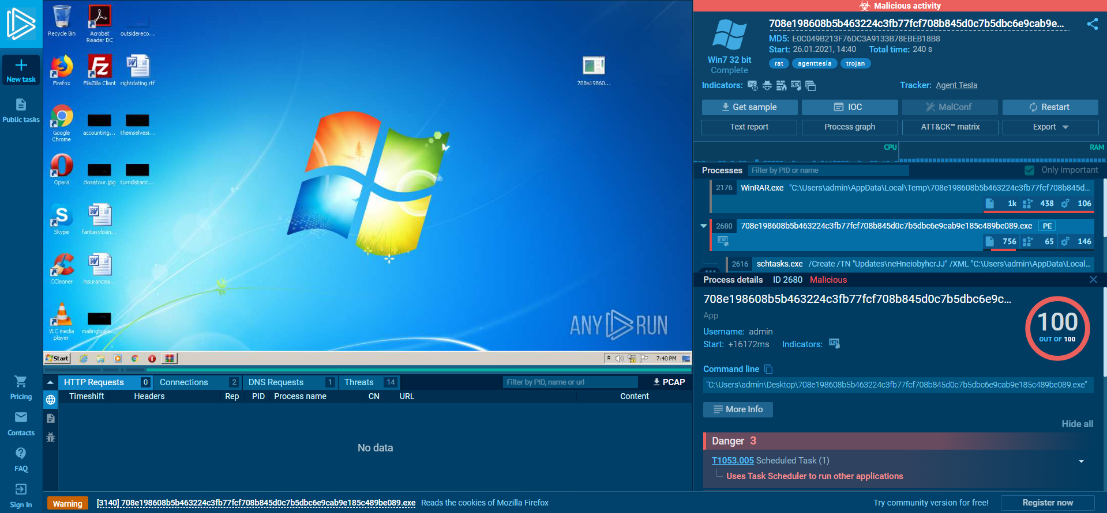

* Network Stream:

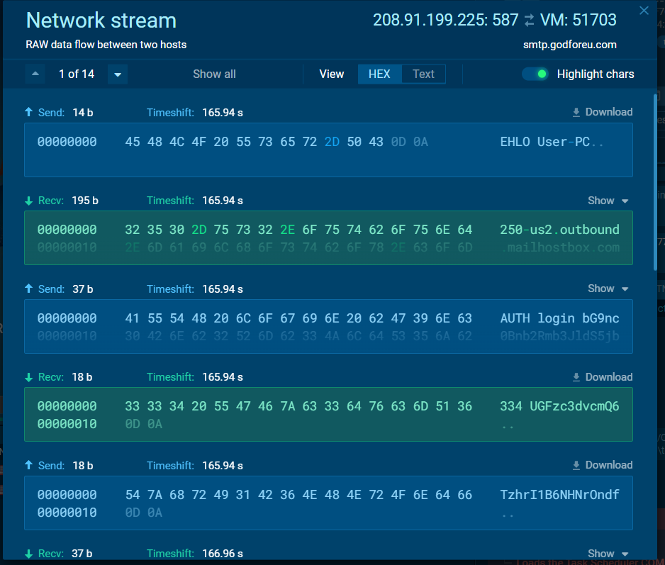

# Security Solutions

**Intrusion Detection System (IDS):**

* Intrusion Detection System (IDS)- Hardware or software used to detect security breaches and attacks by monitoring a network or host
* Types of IDS products:

1. Network Intrusion Detection System (NIDS)- Detects whether traffic is suitable for attacker behavior by passing all traffic on the network through it; an alert is generated whenever abnormal behavior occurs
2. Host Intrusion Detection System (HIDS)- Tries to detect malicious activities by examining incoming and outgoing network packets; an alert is generated whenever abnormal behavior occurs
3. Protocol-Based Intrusion Detection System (PIDS)- Examines client-server traffic
4. Application Protocol-based Intrusion Detection System (APIDS)- Tries to detect security breaches by monitoring communication in application-specific protocols
5. Hybrid Intrusion Detection System (HIDS)- Two or more violation detection approaches are used together

* An IDS is used to detect security breaches according to the detection methods used by the IDS product and to send alerts to the SIEM product.
* Example of Snort (an IDS product) log:

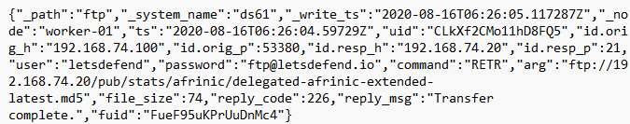

* Another example:

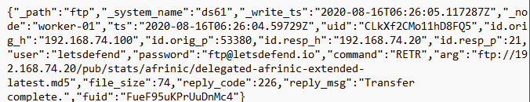

* Extra: The FTP command “RETR” can be used after successfully establishing a data connection to download a copy of a file on the server while the “GET” command copies a remote file on the local computer using the current file transfer type

**Intrusion Prevention System:**

* Intrusion Prevention System (IPS)- Hardware or software that detects security violations by monitoring a network or host and prevents security violations by taking necessary action
* Types of IPS products:

1. Network-Based Intrusion Prevention System (NIPS)- Detects security violations and eliminates them by monitoring all incoming traffic
2. Host-Based Intrusion Prevention System (HIPS)- Monitors and analyzes suspicious activities for a specific host
3. Network Behavior Analysis (NBA)- Detects and blocks unusual traffic flows and DoS attacks on the network
4. Wireless Intrusion Prevention System (WIPS)- Monitors and analyzes wireless network protocol traffic of wireless devices

* The main functions of IPS products are to prevent malicious behavior by detecting security breaches and to notify the relevant authorities of the security breaches encountered during monitoring as an alert
* Example of Suricata (an IPS product) log:

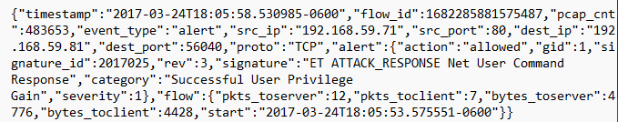

* Another example:

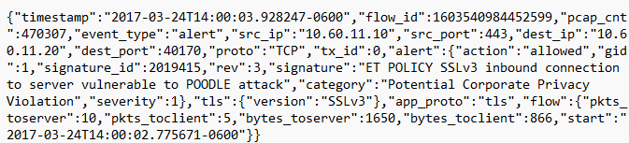

* A third example:

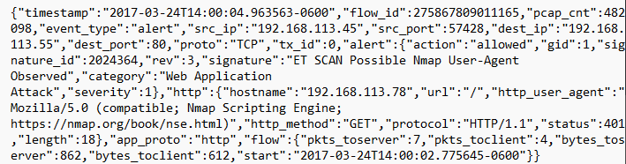

* Extra: A Padding Oracle on Downgraded Legacy Encryption (POODLE) attack occurs when an attacker intercepts the connection between a browser and a web server and forces the browser to downgrade the server’s protocol to SSL 3.0 (as opposed to TLS 1.0), allowing them to steal confidential information

**Firewall:**

* Firewall- Monitors incoming and outgoing network traffic according to rules it contains
* Types of Firewalls:

1. Application-Level Gateways (Proxy Firewalls)- Functions at the application layer between two end systems
2. Circuit-Level Gateways- Verify TCP connections and sessions and operate in the session layer; Easy to be configured, has low resource consumption, and has a simplified structure
3. Cloud Firewalls (also called Firewall-as-a-service or FWaaS)- A firewall service receives over the cloud

* These firewalls have no physical resources so they can be easily reconfigured based on demand or traffic load
* Additional capacity can be added

1. Endpoint Firewalls- Host-based firewall installed on devices

* Often difficult to manage
* This firewall is important component that must be used to ensure security

1. Network Address Translation (NAT) Firewalls- Designed to access internet traffic and block unwanted connections

* Hides the IP addresses in the internal network from the external network (this is where NAT is applied)

1. Next-Generation Firewalls (NGFW)- Combines the features of different firewalls available under the conditions of that day on a single firewall; Designed to block external threats, malware attacks, and advanced attack methods

* Contain a deep-packet inspection (DPI) feature

1. Packet-Filtering Firewalls- Monitors network traffic and filters incoming packets according to configured rules

* Blocks destination port if an incoming packet does not match the rule set
* Cannot block web-based attacks

1. Stateful Multi-Layer Inspection (SMLI) Firewall- Capable of packet inspection, TCP handshake verification, and established connections status
2. Threat-Focused NGFW- Contains all features of a NGFW as well as advanced threat detection features

* Reacts quickly to attacks
* Provides more effective security faster than other firewalls

1. Unified Threat Management (UTM) Firewalls- Stateful inspection firewalls that include antivirus and intrusion prevention

**Endpoint Detection and Response (EDR):**

* An Endpoint Detection and Response (EDR) system constantly monitors the activities in a system, tries to detect security threats such as ransomware and malware, and takes action against malicious activities
* Examples of EDR devices:

1. Desktops
2. Laptops
3. Mobile Devices
4. Tablets
5. Printers
6. IoT Devices

* EDR Core Components:

1. Endpoint data collection agents
2. Automated response
3. Analysis and forensics

* EDR devices contain various log sources such as:
* Processes
* Names of the files accessed by the programs and their access information
* Programs that are run and the files they read and make changes to
* Any other information that may be necessary in terms of security

**Antivirus Software (AV):**

* Antivirus software detects malware on devices and blocks/removes malware from the system before it can harm a device
* Types of antivirus software:

1. Signature-Based Scanning- Software scans the system to detect malware with a digital signature and, is a matching signature is found, the file is then marked as malicious and removed from the system
2. Heuristic Scanning- Monitors the accesses and behaviors of a file as opposed to checking its signature

* Allows for a much higher chance to detect malicious activities

**Sandbox Solutions:**

* A sandbox solution allows potentially malicious files to be executed without harming the actual host itself, allowing security professionals to determine what type of malware the file is
* Benefits:

1. It does not put hosts and operating systems at risk
2. It detects potentially dangerous files
3. It allows testing of software updates before they go live
4. It allows fighting against zero-day vulnerabilities

**Data Loss Prevention (DLP):**

* Types of data loss prevention:

1. Network DLP- Takes security actions related to leaving critical and sensitive information on the network outside the organization
2. Endpoint DLP- Monitors activity on a particular device rather than packet flow within the network
3. Cloud DLP- Prevents sensitive data from leaking over the cloud

**Asset Management Solutions:**

* Asset management solutions are software that can implement all asset management operations such as monitoring the status of assets in the corporate network, maintaining them, and removing them when necessary
* Benefits:

1. Facilitates the implementation of standards
2. Helps with documentation
3. Improves the working performance of assets
4. Provides inventory control
5. Provides strategic decision-making support

* The four main managed IT assets are software, hardware, mobile devices, and the cloud

**Web Application Firewall (WAF):**

* A web application firewall monitors, filters, and blocks any incoming and outgoing packets from a web application
* Types of WAF products:

1. Network-based WAF- Hardware-based on the relevant network

* More expensive

1. Host-based WAF- More customization possibilities; Consumes the resources of the server it is on

* Cheaper

1. Cloud-based WAF- Much more convenient and easy-to-apply security solution than other WAF products

**Load Balancer:**

* A load balancer is a hardware or software product used to distribute server traffic in a balanced way and is placed in front of the servers
* Load balancers provide efficiency, flexibility, reduced downtime, redundancy, and scalability
* Without load balancer:

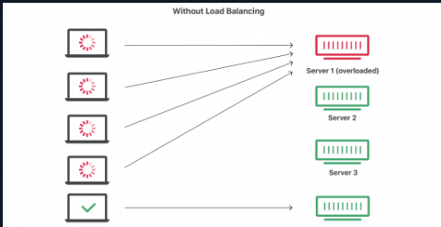

* With load balancer:

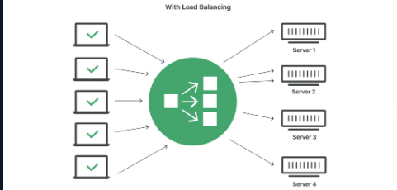

**Proxy Server:**

* A proxy server is hardware or software that acts as a gateway between a client and a server (it also has many other purposes)
* Types of proxy servers:

1. Forward proxy servers- Used to direct requests from a private network to the internet using a firewall

* Most widely used proxy

1. Transparent proxy servers- Directs requests and responses to the target without making any changes to the incoming/outgoing requests and responses
2. Anonymous proxy servers- Enables anonymous internet browsing
3. High anonymity proxy servers- Makes it difficult to track the client with higher confidentiality by not sending the proxy server type and client IP address information in the request
4. Distorting proxy servers- Tries to hide its identity by defining itself as the proxy server of a website (this is done by changing the real IP address)
5. Data center proxy servers- Used as a proxy server that is not connected to the ISP (done by getting service from other data centers)

* Responds quickly and is not meant for anonymity

1. Residential proxy servers- Passes all requests made by the client

* More secure because it blocks all unwanted and suspicious advertisements

1. Public proxy servers- Free proxy server available to everyone

* Sacrifices security and speed and is very insecure

1. Shared proxy servers- Can be used by more than one person at once

* Preferred for fast connection and cost-free use
* One person’s activity can affect another person’s activity

1. SSL proxy servers- Communication is provided in a bidirectional encrypted manner (considered safe)
2. Rotating proxy servers- A separate IP address is assigned to each client
3. Reverse proxy servers- Validates and processes transactions so that the client does not communicate directly with the server
4. Split proxy servers- Runs as two programs installed on two different computers
5. Non-Transparent proxy servers- Sends all requests to the firewall
6. Hostile proxy servers- Used to eavesdrop on the traffic between the client and target on the web
7. Intercepting proxy servers- Allows using the proxy server features and gateway features together
8. Forced proxy servers- Blocking and allowing policies are applied together
9. Caching proxy servers- Contains a caching mechanism on it and returns a response in accordance with the cache in response to the requests sent by the clients
10. Web proxy servers- Works on web traffic alone
11. Socks proxy servers- Prevents external network components from obtaining information about the client
12. HTTP proxy servers- Contains a caching mechanism for the HTTP protocol

* Proxy server benefits:

1. Private browsing
2. Increases user security
3. Allows the client’s IP address to be hidden
4. Allows for management of network traffic
5. Saves bandwidth (saves more with the caching mechanism)
6. Provides access to places with access restrictions

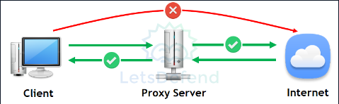

**Email Security Solutions:**

* Functions of email security solutions:

1. Ensuring the security control of the files uploaded to emails
2. Ensuring security checks of URLs found in emails
3. Detecting and blocking spoofed emails
4. Blocking known harmful emails
5. Blocking email addresses with malicious content detected
6. Transmitting information about harmful e-mail content to the relevant product or manager as a warning

# Incident Management 101

**Incident Management Systems (IMS):**

* Incident Management Systems- Where SOC teams conduct the investigation process and record the actions taken when an incident occurs

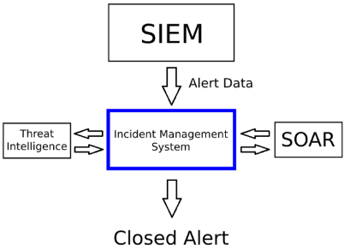

* Workflow, Automation / API access, and close, open, and edit actions are features of the IMS; however, prevention is not

**Case/Alert Naming:**

* A common way to name a case (or ticket) is to put “EventID: ### - [NameOfAlert]” (Ex: EventID: 25 - [SOC15 - Malware Detected])

{Alert ID Number} {Alert Name}

# SEIM 101

**Log Collection:**

* Logs are generally collected in two ways:

1. Log Agents- A software agent that takes action on the logs before forwarding them to the target

* Pros:
* It is a tested and working application created by the developers
* It has many additional features such as auto-parsing, encryption, etc.
* Cons:
* Causes higher resource consumption
* Sys log is a popular network protocol used to transfer logs
* Syslog format:

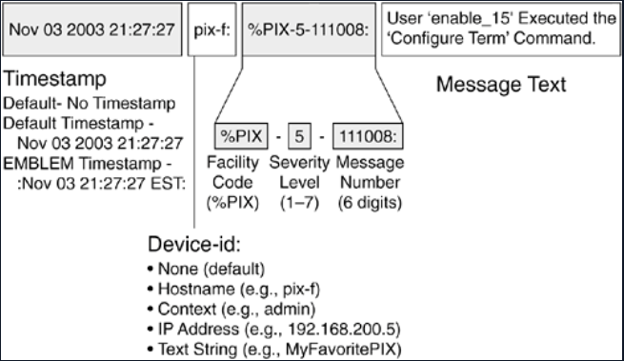

* 3rd party agents like Splunk and ArcSight are also used to integrate SIEM

1. Agentless

* No installation or upgrade cost
* Manual collection may be needed as there are some logs that you cannot collect with an agent, leading you to have to write your own script(s)
* “Universal Forwarder” is the agent software of Splunk

**Log Aggregation and Parsing:**

* Logs are first sent to the log aggregator before they are sent to the destination where they can be edited to filter specific content and get rid of unnecessary information
* From there, log fields are put into the parser area to put them in their places

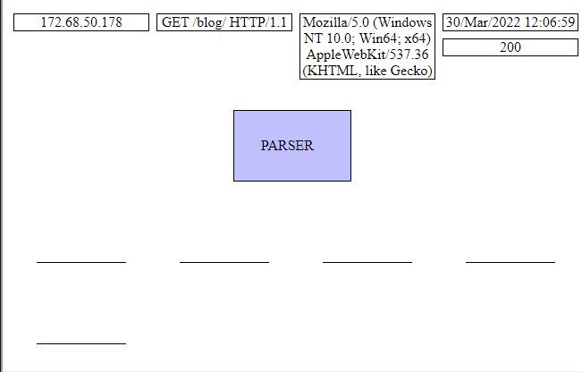

* EPS = Event per seconds = Events/Time period of seconds
* As EPS increases, the aggregator and storage area required also increases
* More than one aggregator can be added so incoming logs do not load the same aggregator
* Parsing/Filtering/Enrichment- The process of processing and directing incoming logs to the target

**Log Storage:**

* High storage size and access speed are very important when creating a SIEM structure
* This can make a huge difference when accessing, for example, a database. If you perform a basic “SELECT * FROM TableName” query on a SIEM structure with slow storage, it could take about 5 minutes to load. However, it will take less than a minute, if not instantly, to load on a SIEM structure with fast storage
* Although the above should be taken into consideration, data update (such as “change value”, “delete value”, etc.) is not very important when discussing SIEM data storage

**Alerting:**

* Alerting techniques:

1. Blacklist- Useful, but very easy to bypass (ex: If a particular file name is blacklisted, the attacker can simply change the file name and an alert will not be triggered)
2. Whitelist- High effective as it only allows for specific traffic; however, it is difficult to manage and the list needs to be constantly updated
3. Long Tail Log Analysis:

* Most common events = Least useful = Do not need to worry about them as much
* Least common events = Most useful = Approach with suspicion

# Splunk

**Introduction to Splunk:**

* Default Splunk ports:
* 9997: Forwarders to the Splunk indexer
* 8000: Clients to the Splunk Search page
* 8089: Splunkd (used by deployment server)
* Splunk has a 60 free trial you can use before you have to pay for it

**Add Data to Splunk:**

* To add data from the forward:
* Go to Settings 🡪 Add Data 🡪 Forward (found at the bottom right of the page) 🡪 Add your computer and give it a Server Class Name 🡪 Select what you want to monitor and the log you want 🡪 Select the index you want the logs to be put 🡪 Review and submit 🡪 Start searching (optional)
* To check your indexes:
* Click Settings 🡪 Indexes
* To add a receiver:
* Click Settings 🡪 Forwarding and receiving 🡪 Add new receiving 🡪 Add the 9997 port 🡪 Search ‘index=“winlog_clients”’ to verify that it worked
* To add data from uploaded logs:
* Click Setting 🡪 Add Data 🡪 Upload (found at the bottom left of the page) 🡪 Add the file you want to upload and click “Next” 🡪 Select host field value and index that will be used (if needed) 🡪 Continue and search to verify (ex: ‘source=“import_logs.csv” host=“WIN-D9CJUS3F2RK” sourcetype=“csv”’)